Journey
Enterprises
Safeguarding
Handbook
Issue  No: | Rev No: | Issue Date | Review Date | Responsible Person
1 | 5 | March 2026 | March 2027 | Operations Manager & Designated Safeguarding Lead

Doc No: INFO-CL-04


Chief Executive Officer:  Safeguarding Trustee:

Introduction


Gemma Sowerby, Designated Safeguarding Lead

“Safeguarding is at the heart of the Care Act 2014 and our operations at Journey Enterprises. All Staff have a responsibility to identify Safeguarding concerns and to record and to report their concerns without unnecessary delay.

Our Safeguarding Handbook has been designed to bring together all our Safeguarding resources in one place, and to include links to further information which will support Staff in their roles.
The Handbook includes Journey’s Safeguarding Adults ‘at risk’ Policy (POL-CL-03)
Safeguarding Adults ‘at risk’ Procedure (PRO-CL-03) Safeguarding
Debrief Form (CL-03-2)

In the closing sections, the Handbook provides:

Guidance on Safeguarding definitions, legislation & processes Links to Local Authority & ADASS1 Safeguarding literature & toolkits Links to NICE2 and SCIE3 guidance & ‘best practice’
Links to specialist disability and carers’ guidance & best practice Links for Staff Whistle-blowers
We hope you will find the Handbook helpful.”

1 Association of Directors of Adult Social Services
2 National Institute of Clinical Excellence
3 Social Care Institute for Excellence

Table of Contents

Pages | Contents
5 - 18 | Safeguarding Adults ‘at risk’ Policy
19 - 30 | Safeguarding Adults ‘at risk’ Procedure
24 - 28 | Safeguarding incident report form
31 - 32 | Safeguarding debrief form
33 - 43 | Definitions of abuse and harm
44 - 45 | Who might cause harm or abuse?
45 - 47 | Spotting signs of abuse and harm
47 - 57 | Unpaid carers and Safeguarding
58 - 62 | Legal powers to intervene
62 | Needs assessments
62 - 64 | Safeguarding adults ‘at risk’ & the Human Rights Act
64 - 66 | Disclosure & Barring Service and Fit & Proper Persons
66 - 67 | Police & Criminal Evidence Act and Appointees
67 - 71 | The Care Act
71 - 81 | Information sharing
81 - 89 | Journey Staff roles & responsibilities
90 - 98 | Glossary of terms used in Safeguarding
99 | Links to Local Authorities advice, information & Policy
99 | ADASS and LGA Resources & Toolkits
100 | NICE and SCIE Guidance & Resources

100 | UK Government Legislation
101 | NHS Resources & Toolkits
101-102 | VCS Resources

Safeguarding Adults ‘at risk’ Policy

Doc No: POL-CL-03

- Safeguarding Policy

The purpose of this document is to set out Journey Enterprises Policy and Procedure to safeguard adults who may be at risk of harm, self-harm, abuse or neglect and young people.

It includes a statement of principles used by Adult Social Care Services, Housing, Health, the Police and other agencies for both developing and assessing the effectiveness of our local Safeguarding arrangements.

Our policy applies to any adult encompassed by the Care Act 2014 who may come in to contact with our service or organisation. This includes Clients, unpaid Carers & Staff with eligible care & support needs

An adult ‘at risk’ is someone who:

  - Has needs for care and support (whether or not they are receiving local authority/NHS services to meet these needs);

  - Is experiencing, or is at risk of, abuse or neglect and

  - as a result of those needs is unable to protect himself/ herself against abuse or neglect or the risk of such harm

- An unpaid carer ‘at risk’ must be someone:

  - whose needs for support arise because they are providing necessary care to an adult with care & support needs;

  - whose physical or mental health is either deteriorating or is at risk of doing so as a result of their caring role;

  - whose wellbeing is being significantly impacted,

An unpaid carer may also be an adult ‘at risk’ because they may have a disability or long-term health condition and/or may be age frail.

Introduction

Safeguarding means protecting a person’s right to live in safety, free from abuse and neglect. The Care Act 2014 requires that we;

  - make Safeguarding referrals into the local authority, or cause others to do so, if it believes an adult is experiencing, or is at risk of, abuse, harm, self-harm or neglect. Any enquiry should establish whether any action needs to be taken to prevent or stop abuse, harm, self-harm or neglect, and if so, by whom;
  - cooperate with all relevant partners in order to protect the Adult. In their turn each relevant partner must also cooperate with the Local Authority.

Journey Enterprises’ policy aims to promote well-being, and to prevent and reduce the risk of significant harm to adults at risk from harm, self- harm, abuse, neglect or other types of exploitation. We will ensure that we support individuals affected to maintain control over their lives and to make informed choices without coercion and observing the requirements of the Mental Capacity Act 2005.

We believe that Safeguarding is everybody’s business. To achieve this, we work within the whole circle of support to most effectively prevent, detect and report harm, self-harm, abuse and neglect of adults ‘at risk’ and young people.

Whilst measures need to be in place to protect those least able to protect themselves, safeguards must also be in place to prevent poor practice ensuring prevention and swift identification of harm, self-harm, abuse & neglect must be an integral part of care and support service delivery.
As an independent charity, we achieve this through working collaboratively with our statutory partners, within the wider Voluntary Community & Faith Sector, with local communities, individual, their families/carers and key workers.

Under the Care Act 2014 the duty to cooperate requires local authorities to set up local Safeguarding Boards and to cooperate with each of their relevant partners using appropriate information sharing protocols. Partners like Journey must cooperate with local authorities and other agencies in order to protect adults with eligible care & support needs who are experiencing or at risk of abuse, harm, self-harm or neglect. To ensure the Organisation responds appropriately across the eight local authorities it currently serves, Journey has a Designated Safeguarding Lead who is also the Operations Manager.

The Designated Safeguarding Lead/Operations Manager is responsible for overseeing and coordinating all internal Safeguarding processes and practice, and for informing and cooperating with all relevant agencies as required by the Act.

These agencies include but are not limited to:

  - local Safeguarding hubs (adults’ and children’s services)
  - Local Authority care managers
  - police & emergency services

Within our Governance structure, the Board of Trustees will appoint a suitably qualified and experienced Safeguarding Trustee. He/she will be responsible for Board oversight of Safeguarding within the Organisation and the links between strategic and operational Safeguarding functions.

The Senior Leadership Team and Board of Trustees are responsible for monitoring & reviewing the effectiveness of this policy and procedure, the Organisation’s Safeguarding systems and practice, and for ensuring all requisite actions are taken during any Safeguarding investigations.
Actions taken under our Safeguarding Policy & Procedure do not affect Journey Enterprises obligations to comply with statutory responsibilities, such as notification to regulatory bodies or compliance with employment legislation. This includes Journey’s duty to report to regulatory bodies such as the Charity Commission (Reporting Serious Incidents Team), and to ensure it has sought all appropriate HR advice in relation to Staff accused of causing harm to an adult ‘at risk’ or to a child.

Principles

Six key principles underpin Journey’s Safeguarding practice:

Empowerment
Personalisation and the presumption of person-led decisions and informed consent: “I am asked what I want as the outcomes from the Safeguarding process and these directly inform what happens.”

Prevention
It is better to take action before harm occurs: “I receive clear and simple information about what abuse is, how to recognise the signs and what I can do to seek help.”

Proportionality
We should use a proportionate and least intrusive response appropriate to the risk presented: “I am sure that the professionals will work for my best interests, as I see them and they will only get involved as much as needed.”

Protection
We work to ensure support and representation for those in greatest need: “I get help and support to report abuse. I get help to take part in the Safeguarding process to the extent to which I want and to which I am able.”

Partnership
Journey Enterprises works in partnership within local communities because communities have a vital part to play in preventing, detecting and reporting harm, self-harm, abuse & neglect: “I know that staff treat any personal and sensitive information in confidence, only sharing what is helpful and necessary. I am confident that professionals will work together to get the best result for me.”

Accountability
Accountability and transparency are central to delivering
effective Safeguarding: “I understand the role of everyone in my life.”

These six principles that underpin Adult Safeguarding apply to all sectors and settings including care and support services, social work, healthcare, welfare, housing providers and the police. The principles should inform the ways in which professionals and other staff work with people at risk of harm, self-harm, abuse or neglect.

Journey Enterprises Safeguarding is also underpinned by other principles, regulatory standards and legislation to which all agencies agree to follow.

These include the:

  - Caldicott Principles
  - Human Rights Act 1998
  - General Data Protection Regulation 2018

Safeguarding means protecting a person’s right to live in safety, free from harm, self-harm abuse and neglect. It is about people, professionals and organisations working together to prevent and stop both the risks and experience of harm, self-harm abuse or neglect, while at the same time making sure that the adult’s wellbeing is promoted. This involves having regard to their views, wishes, feelings and beliefs in deciding on any action. We recognise that people sometimes have complex interpersonal relationships and may be ambivalent, unclear or unrealistic about their personal circumstances.

Journey Enterprises’ Commitment

This policy sets out our commitment to:

  - Work together to prevent and protect adults and young people at risk of harm, self-harm, abuse or neglect.

  - Empower and support people to make their own choices.

  - Respect confidentiality except where there is risk of serious harm to self or others.

  - Accept that the right to self-determination can involve risk but ensure that such risk is assessed, recognized and understood by all concerned.

  - Seek to minimize risks through open discussion between the individual, their families & carers, and with professionals. We will review the risks involved and offer appropriate help.

  - Work with our local Safeguarding hubs in line with the Safeguarding Adults Ten Steps Framework. Meeting our commitments under the Care Act 2014, Journey will cooperate, share information, and comply fully with any investigation in to actual or suspected harm, self-harm, abuse or neglect of adults ‘at risk’.

  - Support and protect adults who are experiencing harm, abuse or neglect.

The responsibilities of organisations working together to safeguard adults ‘at risk’:

Observant Staff making early, positive interventions with individuals, families & carers can make a huge difference to their lives, preventing the deterioration of a situation or breakdown of a support network. It is often when people become increasingly isolated and cut off from families, carers and friends that they become extremely vulnerable to harm, self- harm, abuse and neglect.

Identifying, Reporting & Cooperating

Everyone to whom this document applies needs to be aware that doing nothing is not an option. All Journey Staff, employees & volunteers, have a duty to report any concerns or suspicions that an adult or child is being, or is at risk of being, harmed without delay.

Our Safeguarding Procedure (PRO-CL0-03) adopts the principles of a local authority Safeguarding Adults Ten Step Framework. It sets out our three-step process, defining actions, time-scales and responsibilities of Staff to identify & refer Safeguarding incidents, and to liaise with external agencies.

Our Procedure identifies specific actions for three channels of incident:

  - Safeguarding allegations
  - Emergency incidents
  - Safeguarding allegations made against Journey Staff

By identifying and channelling incidents appropriately at first stage, we aim to reduce the scope of risk to the individual or individuals, and ensure evidence is secured.

All Staff must identify and report Safeguarding concerns immediately.

All managers must report Safeguarding incidents to their local Safeguarding Hub within 24 hours.

All Staff must have completed relevant Safeguarding training before deployment and must undertake refresher training at three yearly intervals.

The Designated Safeguarding Lead must have completed Safeguarding Leadership training and have relevant professional qualification and experience to lead Safeguarding of adults.

The Senior Leadership Team and Board of Trustees will ensure the Organisation co-operates effectively in any enquiry relating to an adult deemed to be at risk or where there are Safeguarding concerns brought to the attention of the Local Authority or Police, regardless of whether the Local Authority or NHS provides care & support services to the individual.

Adults who may be at risk of abuse, harm or neglect

An adult ‘at risk’ is someone who, as defined in the Care Act 2014:

  - Has needs for care and support (whether or not they are receiving local authority/NHS services to meet these needs);

  - Is experiencing, or is at risk of, abuse or neglect and

  - as a result of those needs is unable to protect himself/ herself against abuse or neglect or the risk of such harm.

Within our service, adults ‘at risk’ include Clients, unpaid Carers & Staff with eligible care & support needs.

The Adult may be a person who has one or more of the following characteristics:

  - has a disability/disabilities (i.e. learning disability, mental health disability, physical & sensory disability)
  - is age-frail
  - has a long-term condition/illness
  - is an unpaid carer who may be age-frail, have a disability or be supporting an individual whose behaviours cause harm to the carer
  - is unable to demonstrate the capacity to make a decision and is in need of care and support
  - misuses substances or alcohol

This does not mean that just because a person is age-frail, a carer, substance dependency or has a disability that they are inevitably at risk of harm, self-harm, abuse or neglect. For example, a person with a disability who has mental capacity to make decisions about their own safety could be perfectly able to make informed choices and protect themselves from harm.

In the context of Safeguarding Adults, the vulnerability of the Adult is related to how able they are to make and exercise their own informed choices free from duress, pressure or undue influence of any sort, and to protect themselves from abuse, neglect and exploitation. It is important to note that people with capacity can also be vulnerable. An Adult’s vulnerability is determined by a range of interconnected factors including personal characteristics, factors associated with their situation or environment and social factors.

Staff at Journey must be aware that harm and abuse can happen in any setting and may present as self-harm and self-neglect. Adults at risk may be harmed at home, within another’s home, within their local community, at college or at work, in day, residential or other services. They may be harmed, self-harm or be persuaded to self-harm.

Potential perpetrators include:

    - Family, friends and neighbours
    - Unpaid carers (family, friend, neighbour)
    - Paid carers and support workers
    - Professionals/workers within an organisation including Journey
    - Someone within the community (known or unknown to the adult)
    - Someone remote from the community including on-line perpetrators
    - Other ‘adults at risk’

Working with Adults at risk of abuse, harm or neglect

Journey Enterprises’ handling of Safeguarding allegations will be appropriate to the adults ‘at risk’ and not discriminate because of disability, age, gender, sexual orientation, ethnicity, religion or belief, culture or lifestyle.
The primary focus/ point of decision-making should be as close as possible to the Victim. Individuals must be supported to make choices.

There is a presumption that adults have mental capacity to make informed decisions about their lives. If someone has been assessed as not having mental capacity, decisions will be made in their best interests, as set out in the Mental Capacity Act 2005 and Mental Capacity Act Code of Practice.

Adults should be given information, advice and support in a form that they can understand and can act upon. Building upon best practice within the Triangle of Care, their views must be included in all forums that are making decisions about their lives.

All decisions taken by professionals about a person’s life should be timely, reasonable, justified, proportionate and ethical.

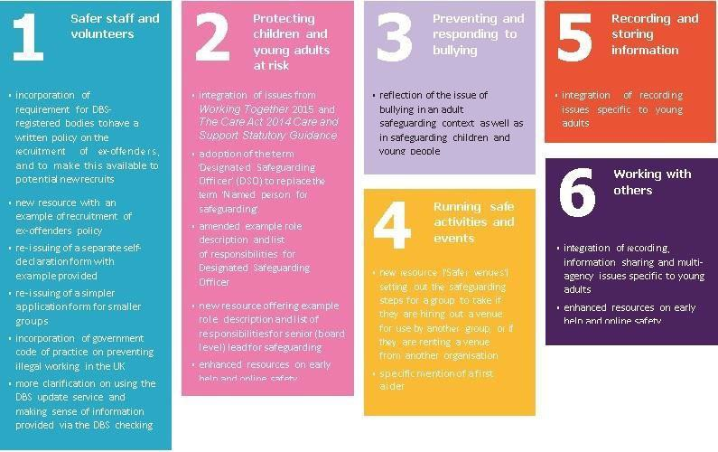

Safeguarding Adults ‘at risk’ Procedure

Doc No: PRO-CL-03

Overview
Our Safeguarding Procedure is part of our Safeguarding Handbook and must be followed by all Staff (employees & volunteers).
Journey Enterprises Staff must be able to identify abuse, harm, self-harm or neglect in adults ‘at risk’ and young people, and take appropriate action without delay.

The Procedure has four steps:

    - All Staff Actions: First Steps
    - All Staff Actions: Follow-up
    - Managers & Senior Leadership Actions: Next Steps
    - Managers & Senior Leadership Actions: Follow-up

All Staff: First Steps

    - If someone is a victim of potential crime or has a health emergency, you must follow the red pathway below and call 999.

    - If the harm is being caused by someone who is not a member of our Staff you must follow the green pathway below.

    - If the harm is being cause by someone who is on our Staff Team you must follow the orange pathway below.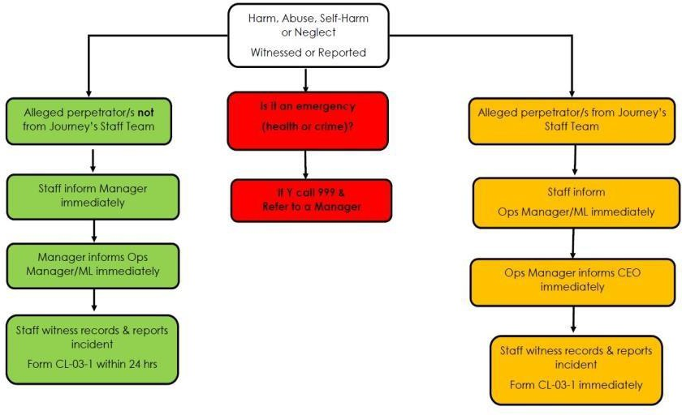

All Staff: Next Steps
- Charitylog: record a diary entry under the project, Safeguarding.
- Add the appropriate Classification Codes at the end of your diary entry.
- Complete the Safeguarding report which is an Extension Database at the foot of the Client’s individual record on Charitylog.

Managers & Senior Leadership: Next Steps
Managers & the Senior Leadership Team are responsible for managing Safeguarding incidents, informing regulators and ensuring Staff are linked to appropriate support.

    - If someone is a victim of potential crime or has a health emergency managers/Ops Manager must follow the red pathway below.
    - If the harm is being caused by someone who is not a member of our Staff managers/Ops Manager must follow the green pathway below.
    - If the harm is being caused by someone who is on our Staff Team the CEO & Board must follow the orange pathway below.
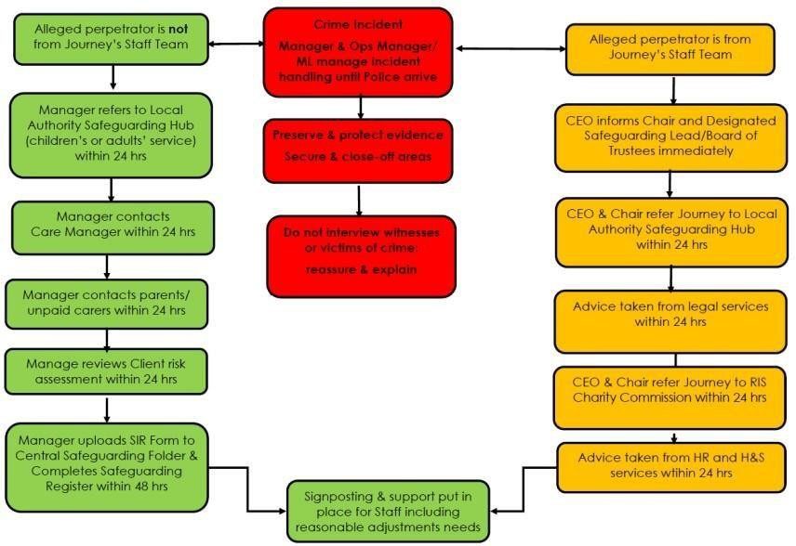

Managers & Senior Leadership: Follow-up Actions
Managers & the Senior Leadership Team oversee follow-up actions including internal investigations, cooperation with statutory agencies conducting investigations and regulators.

    - If the harm is being caused by someone who is not a member of our Staff managers/Ops Manager must follow the green pathway below.

    - If the harm is being caused by someone who is on our Staff Team the CEO & Board must follow the orange pathway below.
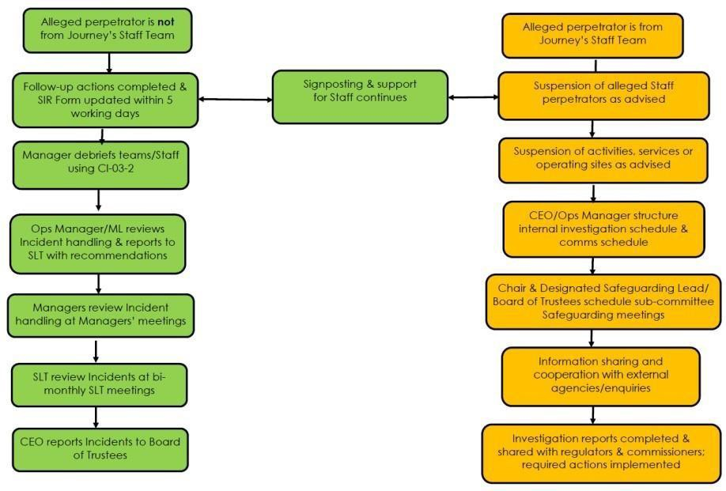

Charitylog Follow-up Actions

  - Open the Client record and the relevant Safeguarding Report: this is an extension database at the foot of the Client’s record.
  - Complete the follow-up actions on this record.

Handling Incidents: Do’s and Don’ts

DO |  | DON’T
Make sure the immediate safety of the person, calling 999 if a crime is suspected or medical attention required |  | Be judgmental (for example, “why didn’t you stop them…”) or jump to conclusions
Stay calm and do not show shock or disbelief |  | Agree to keep secrets or make promises that you will be unable to keep
Listen carefully to what you are being told and ask, if appropriate, what the person  wants to happen |  | Assume the person lacks capacity to make their own decisions
Tell the person:  - They did the right thing in telling you  - It was not their fault |  | Show them photos of possible abusers or ask closed or leading questions (as this may prejudice any criminal investigation later)
Treat the person with dignity and respect, keeping them informed throughout |  | Interrogate or press the person for more details
Preserve evidence e.g. paperwork, clothing, blood, semen, etc. |  | Contact the alleged abuser or alleged victim (depending on who is making the disclosure)
Explain that you are required to share this information with the Operations Manager/Safeguarding Lead and Local Safeguarding Hub and, as required, Police or Ambulance/NHS services |  | Pass on the information to anyone other than people that ‘need to know’
Explain that further investigations will be conducted sensitively and with their involvement as much as possible | ‘Sit’ on the information over the weekend or until you are on duty next, make sure you report the information as soon as possible.
Write down what the person has said remembering that this information may be used as evidence. | Deviate from Journey Enterprises’ Safeguarding Policy and Procedure

  - Safeguarding Incident Forms: How to Complete Page 1 of the Incident Report Form
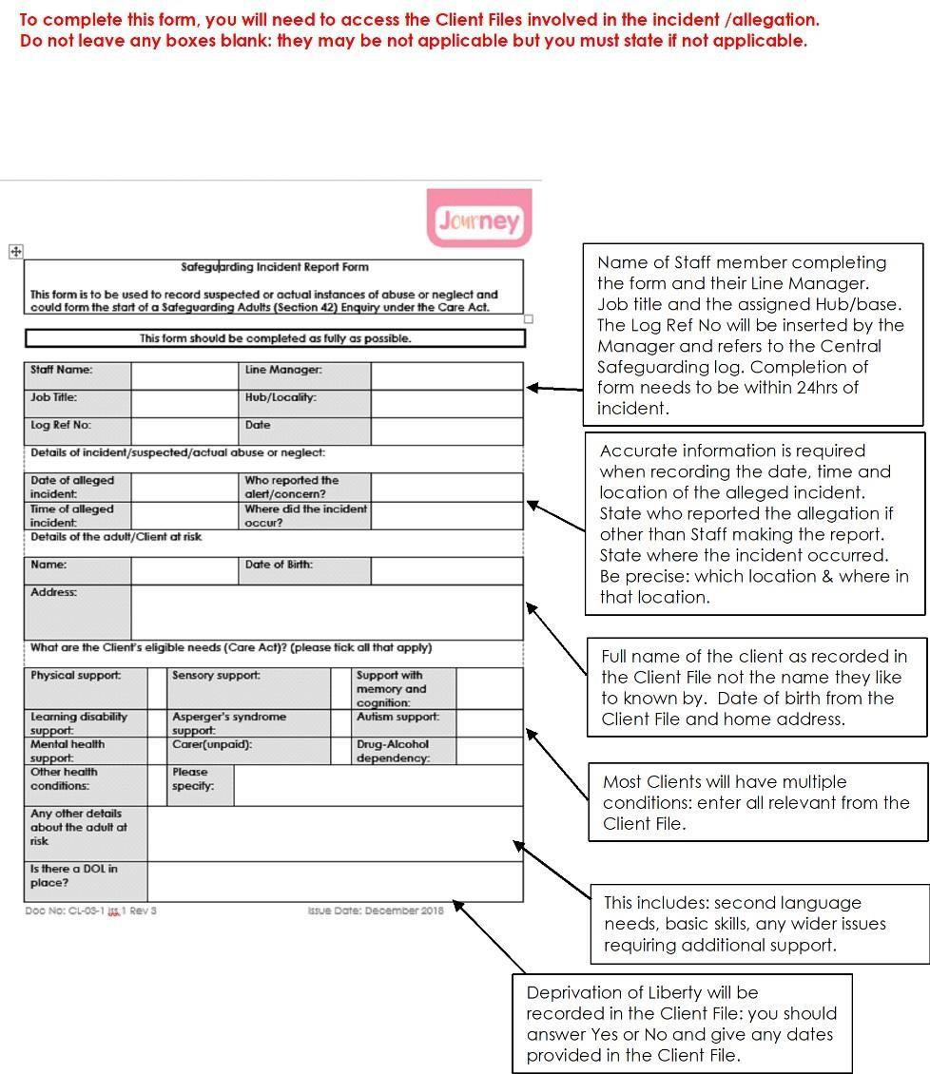

Page 2 of the Incident Report Form

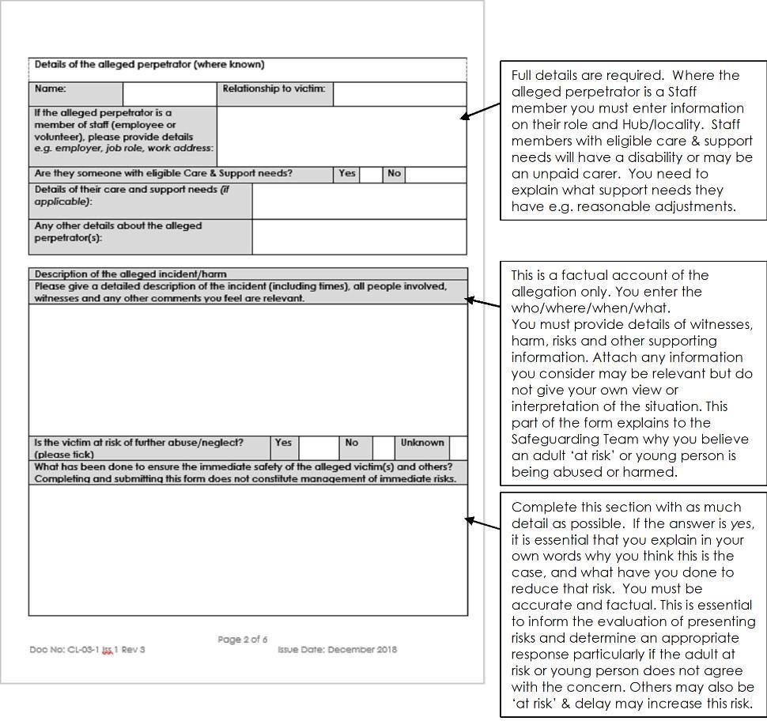

Page 3 of the Incident Report Form

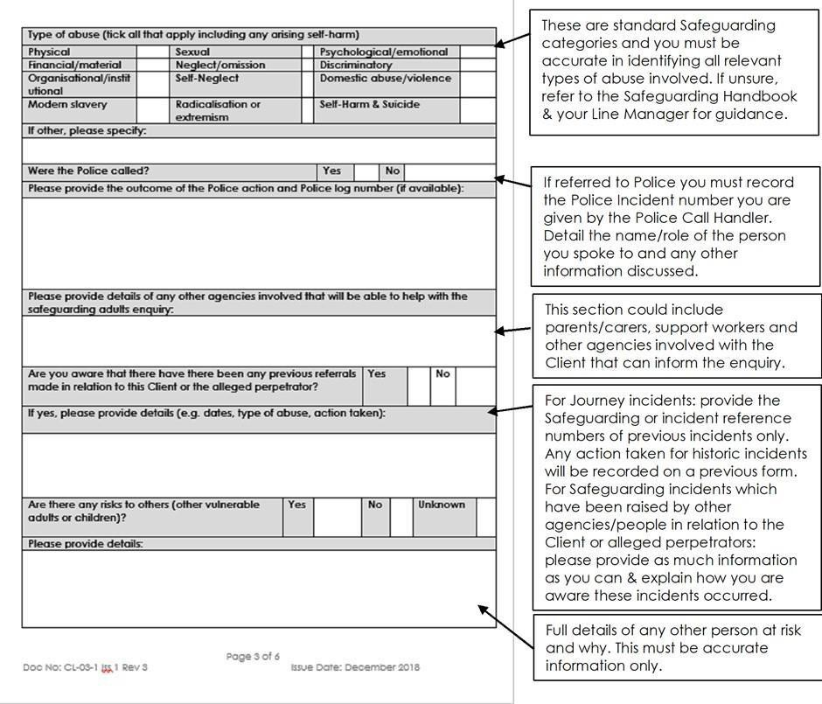

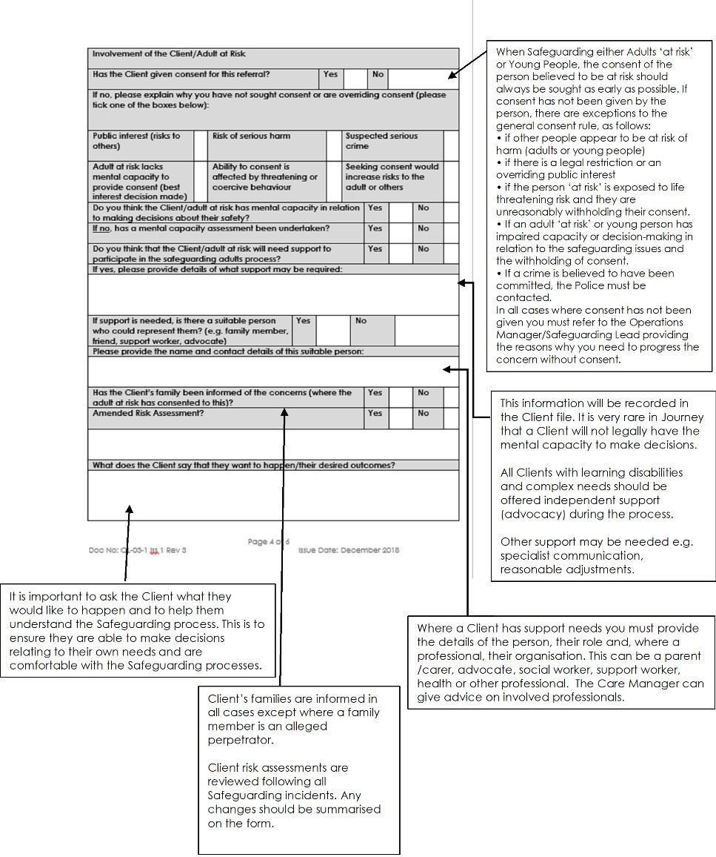
Page 4 of the Incident Report Form

Page 5 of the Incident Report Form

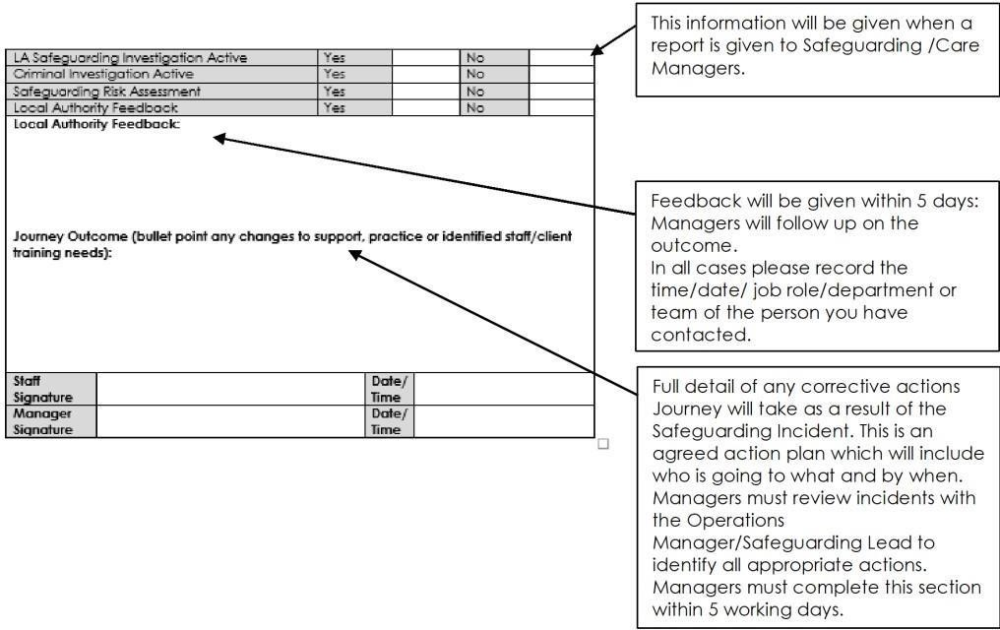
  - Safeguarding Contacts

Journey Enterprises: Gemma Sowerby
Operations Manager & Safeguarding Lead gemma.sowerby@journeyenterprises.co.uk
T: 01434 724036/ 07703 684 264

Local Authority Safeguarding ADULTS
Darlington 01325 406111 & 01642 524552 (Duty Team)
Durham 03000 267 979 (24/7)
Gateshead 0191433 7033 (24/7)
Newcastle 0191 278 8377 adults & 0191 278 7878 (Duty Team)
North Tyneside 0191 643 2777 & 0330 333 7475 (Duty Team)
Northumberland 01670 536 400 (24/7)
South Tyneside 0191 424 6000 (office hours) or 0191 456 2093 (out of office hours)
Sunderland 0191 561 8934 or 0191 561 8936 (office hours) or 0191 520 5553
(out of office hours)

Emergencies
  - If the Safeguarding concern is a medical emergency or a crime you must contact 999 without delay.

  - If you are not sure about whether or not a criminal offence has taken place, contact Police Non-Emergency 101(24/7).

  - If you are unsure if it is a medical emergency contact 111.

Support for Staff during Safeguarding Processes

Information, advice and counselling:

  - Journey’s Employee Assistance Programme: Benenden Health, Mental Health Helpline
  - T: 0800 414 8247

Information, advice and support for whistle-blowers:

  - Protect
T: 020 3117 2520, and website: https://www.pcaw.org.uk An online advice form is available via:
https://www.pcaw.org.uk/contact-protect-advice-line/

Incidents involving Journey Staff

Charity Commission

  - Safeguarding@charitycommission.gov.uk
  - RSI@charitycommission.gov.uk

Northumberland Multi Agency Safeguarding Hub -

onecall@northumbria.nhs.uk

Safeguarding Incident Debriefing Form

Incident Report No.: | Incident Date:
LSC: | Hub Team:

Summary of Incident: Bullet Points Only
•

•
Incident Code
Incident Discussion: What went well?
What did not go well?

Discussion must include: | Staff: reactions, behaviours, feelings, thoughts & suggestions  Identify the learning  Identify support needs include training and additional support sessions
Actions Required/Lessons Learnt

Tick relevant

Improving or changing communications (Staff to Staff, Staff to Client/Carers or Staff to agencies externally)
Staff training
[please outline what training is required]:
Changes to wider systems or procedure [provide brief detail]:
Increased support systems for Staff including reasonable adjustments
Self-referral to EPA
Safeguarding Incident Debriefing Sign-Off: Manager Name: Click or tap here to enter text.

Staff Name(s): Click or tap here to enter text.

Date: Click or tap here to enter text.


Safeguarding Guidance & Resources

Definitions: Abuse, Harm and Neglect

  - Different types & patterns

This section considers the different types and patterns of abuse, harm and neglect and the different circumstances in which this may take place.

Abuse, harm and neglect can take many forms:

  - Physical abuse
  - Sexual abuse
  - Psychological abuse
  - Exploitation – either opportunistically or premeditated, unfairly manipulating someone for profit or personal gain;
  - Financial or material abuse
  - Neglect and acts of omission
  - Discriminatory abuse
  - Institutional or Organisational abuse
  - Modern day slavery
  - Self-neglect
  - Self-harm
  - Domestic abuse
  - Radicalisation

This is not intended to be an exhaustive list but an illustrative guide as to the sort of behaviour which could give rise to a Safeguarding concern.

Examples of Abuse

    - Physical abuse - This is the physical ill treatment of an adult ‘at risk’ which may or may not cause physical injury. Examples of physical abuse are hitting, pushing, pinching, shaking, misusing medication, scalding, the misuse or illegal use of restraint, inappropriate physical sanctions, exposure to heat or cold and not giving adequate food or drink.

    - Restraint - Unlawful or inappropriate use of restraint or physical interventions and/or deprivation of liberty is physical abuse. There is a distinction to be drawn between restraint, restriction, and deprivation of liberty. A judgement as to whether a person is being deprived of liberty will depend on the particular circumstances of the case, taking into account the degree of intensity, type of restriction, duration, the effect and the manner of the implementation of the measure in question.

The “acid test” for a deprivation of liberty is that the person is subject to continuous supervision and control, and is not free to leave. In extreme circumstances unlawful or inappropriate use of restraint may constitute a criminal offence. Someone is using restraint if they use force, or threaten to use force, to make someone do something they are resisting, or where a person’s freedom of movement is restricted, whether they are resisting or not.

Restraint covers a wide range of actions. It includes the use of active or passive means to ensure that the person concerned does something, or does not do something they want to do, for example, the use of key pads to prevent people from going where they want from a closed environment.

Appropriate use of restraint can be justified to prevent harm to a person who lacks capacity as long as it is a proportionate response to the likelihood and seriousness of the harm. Providers of health and social care must have in place internal operational procedures covering the use of physical interventions and restraint incorporating best practice guidance and the Mental Capacity Act, Mental Capacity Act Code and the Deprivation of Liberty Safeguards (DoLS).

    - Sexual Abuse - includes rape and sexual assault or sexual acts to which the adult ‘at risk’ has not consented or was pressured into consenting or was not of legal age to consent. It may also include direct or indirect involvement including being required to watch sexual activity and sexual exploitation.

Key principles:

- Sexual relationships or inappropriate sexual behaviour between a member of Staff and a Journey Client/adult ‘at risk’ or young person are always abusive and will lead to disciplinary proceedings. This is additional to any criminal action that is being taken. A sexual relationship between a Client and a designated care worker or professional involved in the care of the adult ‘at risk’ (other than one which existed legitimately immediately before the worker became involved in the service user’s care) would constitute the commission of one or more criminal offences under sections 38 to42 of the Sexual Offences Act 2003.

- There may be Safeguarding adults’ alerts that involve sexual innuendo or remarks that will not result in a criminal investigation; however, all Safeguarding adults’ alerts that indicate any form of sexual abuse require a risk assessment, intelligence gathering and appropriate information sharing with relevant partners.

    - Sexual Exploitation - Sexual exploitation means taking the advantage of sexuality and attractiveness of a person to make a personal gain or profit. It is the abuse of a position of being at risk, differential power, or trust for sexual purposes.
    - Psychological / Emotional Abuse - Psychological or emotional abuse includes threats of harm or abandonment, deprivation of contact, humiliation, blaming, controlling, intimidation, coercion, harassment, verbal abuse, isolation or unreasonable and unjustified withdrawal of services or supportive networks.
Psychological or emotional abuse is the wilful infliction of mental distress by a person who is in a position of trust and power to that person.
Psychological/emotional abuse results from threats of harm or abandonment, being deprived of social or any other sort of contact, humiliation, blaming, controlling, intimidation, coercion, harassment, verbal abuse, isolation and bullying, including withdrawal of services.

Psychological abuse is a type of abuse which harms the victim’s self- esteem and results in them being less able to protect themselves and exercise choice. It is a type of abuse that can result from other forms of abuse and often occurs at the same time as other types of abusive behaviour.

This is behaviour that has a harmful effect on the person’s emotional health and development or any form of mental cruelty that results in:

- the denial of basic human and civil rights such as self-expression, privacy and dignity
- negating the right of the person to make choices and undermining their self-esteem
- isolation and over-dependence that has a harmful effect on the person’s emotional health, development or wellbeing.

Behaviour that can be deliberately linked to causing serious psychological and emotional harm may constitute a criminal offence. Specialist advice from the police should be sought.

    - Financial / material abuse - Financial abuse is the use of a person’s property, assets, income, funds or any resources without their informed consent or authorisation, and may amount to a crime, depending on the circumstances.

It includes:
  - theft
  - fraud
  - exploitation
  - undue pressure or coercion in relation to a person’s affairs including wills, property, inheritance or financial transactions;
  - failure to act in best interest in relation to a person’s financial affairs where acting as a legal Appointee, friend or family member;
  - the misuse or misappropriation of property, possessions or benefits

Potential indicators of financial abuse include:
  - lack of heating, clothing or food;
  - changes in living conditions;
  - inability to pay bills/unexplained shortage of money;
  - inability to purchase normal items for quality of life & choices;
  - unexplained withdrawals or activities from an account;
  - unexplained transfers from an adult’s account to other adults’ accounts;
  - unexplained loss/misplacement of financial documents;
  - the recent addition of authorised signers on a client or donor’s
  - signature card;
  - sudden or unexpected changes in a will or other financial documents;
  - lack of records and accounting of where money has been spent;
  - withholding money including Client’s access to personal monies;
  - recent change of deeds or title of property;
  - unusual interest shown by family or others in the person or their assets
  - person managing financial affairs is evasive or uncooperative i.e. family members, friends, appointees;
  - selling or offering to sell possessions of a vulnerable adult who does or have the capacity to consent or know their value.

This is not an exhaustive list of indicators of financial abuse, nor do these examples prove that there is actual abuse occurring.

However, they do indicate that a closer look and possible investigation may be needed.

Within our service it is essential that Staff in different roles and departments share information relating to potential financial abuse concerns as soon as these are identified. All Staff are required to report concerns in the first instance to their line manager. In the case of suspected crime, the Police must be informed as soon as possible whilst also referring in to the Local Safeguarding Hub. Review of reported financial concerns relating to adults ‘at risk’ is a standing item on team meetings, managers’ meetings, senior leadership meetings and meetings of the Finance & Risk Sub Committee/Board of Trustees.

Journey Enterprises receives Client monies for day services, transportation and lunches through its Finance Department. Client monies for activities and events are processed by Business Administrators. Clients’ personal money for use during the day is the responsibility of the Client.

Staff are asked to be particularly vigilant where we are aware of family members, non-statutory Appointee ships or
Guardianships holding responsibility for administering the adult’s financial affairs and benefits.

Journey expects all to act in the adult’s best interest:

- to pay in a timely manner for the day services which the adult has received and not to accrue debt/arrears on their behalf;

- to pay in a timely manner for the transportation services which the adult has received and not to accrue
debt/arrears on their behalf;

- to provide appropriate amounts of the Client’s monies in order to meet the Client’s choices for mealtimes (where provided by Journey), light refreshments (at Journey and within community activities), events and special activities which the Client has expressed interest in undertaking;
- to provide appropriate amounts of the Client’s monies for the Client’s own use to purchase refreshments, small items and any other needs meeting the Client’s choices during the day and/or evenings;

- to provide appropriate amounts of the Client’s monies for their enjoyment of an annual holiday or break of their choice.

    - Neglect and acts of omission - Neglect is the failure of any person who has responsibility for the charge, care or custody of an adult with care & support needs or a young person. He/she has failed to provide the amount and type of care that a reasonable person would be expected to provide.

Behaviour that can lead to neglect includes including ignoring medical or physical needs, failing to allow access to appropriate health, social care and educational services, and withholding the necessities of life such as medication, adequate nutrition, hydration or heating.

An allegation of abuse or neglect of an adult who does not have capacity to consent on issues about their own safety will always give rise to action under the Safeguarding Adults process and subsequent decisions made in their best interests in line with the Mental Capacity Act and Mental Capacity Act Code as outlined above.
The Mental Capacity Act 2005 created the criminal offences of illtreatment and wilful neglect in respect of people who lack the ability to make decisions.

The offences can be committed by anyone responsible for that adult’s care and support. Section 44 of the Act states that these offences are punishable by fines or imprisonment. Ill treatment covers both deliberate acts of ill-treatment and also those acts which are reckless which results in ill-treatment.

Wilful neglect requires a serious departure from the required standards of treatment and usually means that a person has deliberately failed to carry out an act that they knew they were under a duty to perform.

Discriminatory Abuse - Discriminatory abuse exists when values, beliefs or culture result in a misuse of power that denies opportunity to some groups or individuals. It can be a feature of any form of abuse of an adult ‘at risk’ or young person, but can also be motivated on grounds of race, ethnic origin, gender, gender identity, sexual orientation, age, disability, religion and other discriminatory factors.
It can result from situations that exploit a person’s vulnerability by treating the person in a way that excludes them from opportunities they should have as equal citizens, for example, education, health, justice and access to services and protection.

    - Institutional or Organisational Abuse - includes neglect or poor care practice within an institution or specific care setting like a hospital, special school/college or care home for example, that violate the person’s dignity. This may range from isolated incidents to continuing ill-treatment.
Organisational abuse occurs when the routines, systems and regimes of an institution result in poor or inadequate standards of care and poor practice which affects the whole setting and denies, restricts or curtails the dignity, privacy, choice, independence or fulfilment of adults, resulting in lack of respect for their human rights.

Organisational abuse can occur in any setting providing health and social care and within educational services. It is most likely to occur when there is poor management and staff are poorly supported, supervised, trained and guided in their work.

The risk of abuse is potentially greater in a service;

- with inadequate recruitment practices & employment checks
- with inadequate induction, training & Staff supervision practices
- with inadequate monitoring & appraisal practices
- with inadequate staffing numbers including poor levels of management supervision
- in a service with high Staff turnover and/or use of Relief Staff
- where a service deploys a high ratio of Staff lone working or remote working with adults ‘at risk’ which use rigid routines and inflexible practices
- which do not use person-centred care plans
- where there is a closed culture.

Institutional Abuse can occur in any Organisation: this includes Journey Enterprises. To ensure Journey prevents and can quickly identify Institutional Abuse within its own service the Organisation has:

- Safer Recruitment and Fit & Proper Persons Retention procedures;

- Appropriate policy, procedure and systems to prevent, identify and address any potential abuse or harm caused to an adult ‘at risk’ by a member of our Staff;

- A formal chain of reporting & accountability between the Board of Trustees, Operational Team, Senior Leaders and Managers, and wider Staff;

- Safer deployment & role design to ensure Safeguarding is embedded in practice and is everyone’s responsibility;

- Structured training, supervision & support systems to ensure Staff undertake their roles with due regard for the dignity, respect and Safeguarding of Clients and wider adults who may be in contact with Journey’s service;

- Appropriate site & activities design. Journey Staff work with adults ‘at risk’ in a 1:8/group ratio (Staff/Clients) in open activities rooms, amongst wider operations. This reduces the risk of abuse within a 1:1 setting;

- Channels for adults ‘at risk’ to raise concerns that they are being abused or harmed. These include Easy Read Safeguarding literature, Client Forums and an open-door policy for Clients to raise concerns with a Staff member, Manager or Senior Manager at any stage;

- A Whistleblowing Policy (POL-HR-17) to enable Staff reporting potential harm or abuse by colleagues can do so safely and confidentially, and to receive appropriate support during the process.

    - Modern day slavery – encompasses slavery, human trafficking, forced labour and domestic servitude. Traffickers and slave masters use whatever means they have at their disposal to coerce, deceive and force individuals into a life of abuse, servitude and inhumane treatment.

    - Self-neglect – this covers a wide range of behaviour neglecting to care for one’s personal hygiene, health or surroundings and includes behaviour such as hoarding.

Domestic Abuse
Domestic abuse is physical, psychological, sexual or financial abuse that takes place within an intimate or family-type relationship. It is the repeated, random and habitual use of coercive behaviour and intimidation to control a partner or other person within the relationship. Abusers are usually a person's spouse, partner, ex-spouse, ex-partner, carer or other close family member. Most people affected by domestic abuse are women, but many men are abused by their partners. Domestic abuse can happen in straight, lesbian, gay, bisexual, transgender, queer and intersex relationships. Domestic abusers can also be adults ‘at risk’.

Radicalisation
Radicalisation is where the adult ‘at risk’ or young person is influenced, exposed to & coerced to support terrorism and extremist ideologies associated with terrorist groups. Extremism is vocal or active opposition to fundamental British values, including democracy, the rule of
law, individual liberty and mutual respect and tolerance of different faiths and beliefs. We include calls for the death of members of our armed forces whether in the UK or abroad (HM Government Prevent Strategy 2011). Radicalisation can occur within the community, within an institution or organisation, within a family or familial network, close to home or remotely.

    - Intentional/unintentional abuse - Abuse or neglect may be deliberate, or the result of negligence or ignorance. Unintentional abuseor neglect arises, for example, because pressures have built up and/or because of difficult or challenging behaviour which is not being properly addressed.

The intent of the abuse or neglect is likely to inform the type of response. For example, it is important to recognise unintentional abuse or neglect and this may include considering the impact of stress on a carer’s ability to care for another person. This includes
strains on young carers who may have taken on age inappropriate roles.

Depending on the circumstances the appropriate response where unintentional abuse takes place could be a support package for a carer or young carer, but in another circumstance in which Safeguarding concerns arise from harm suffered as a result of abuse which was intended to cause harm then it would be necessary to consider whether to refer the matter to the police to consider whether a criminal investigation would be required or appropriate.

Who might harm or abuse?

Staff at Journey need to be aware that harm and abuse can happen in any setting and may present as self-harm and self-neglect. Adults at risk may be harmed at home, within another’s home, within their local community, at college or at work. They may be harmed or abused in day, residential or other services. They may be harmed, self-harm or be persuaded to self-harm.

Abuse can happen in any context and it is important to understand the circumstances of abuse, such as whether others may be at risk of abuse, whether others have witnessed abuse and the role of family members, paid staff and professionals.

Potential perpetrators include:

    - Family, friends and neighbours
    - Unpaid carers (family, friend, neighbour)
    - Paid carers and support workers
    - Professionals/workers within an organisation including Journey
    - Someone within the community (known or unknown to the adult)
    - Someone remote from the community including on-line perpetrators
    - Other ‘adults at risk’

Patterns and frequency of harm and abuse vary. We may see:
  - Serial abusing in which the perpetrator seeks out and ‘grooms’ individuals. Sexual abuse sometimes falls into this pattern as do some forms of financial abuse;
  - Long-term abuse in the context of an ongoing family relationship such as domestic violence between spouses or generations or persistent psychological abuse;

  - Opportunistic abuse such as theft occurring because money or jewellery has been left lying around.

Incidents of abuse may be one-off or multiple, and affect one person or more. It is essential that Staff have the skills and knowledge to look beyond single incidents to identify potential patterns of harm.

Repeated instances of poor care /lack of money, for example, may be an indication of more serious problems or of what we now describe as institutional or organisational abuse. In order to see these patterns, it is important that information is recorded, shared and acted upon within Journey.

Journey has a central Safeguarding Log in which all Safeguarding Incident Report Forms are saved and a central Register held. The Designated Safeguarding Lead/the Operations Manager is responsible for reviewing Report Forms and Register to assess patterns of incidents in addition to reviewing handling of incidents. Following this review, the Operations Manager may raise a further alert with the Local Safeguarding Hub, Care Managers and, where required, a Client’s family/carer.

1.4 Spotting signs of abuse, harm and neglect

Staff at Journey must place Safeguarding at the heart of their delivery. We want all Staff to act upon their concerns as soon as a risk is identified. We want our Staff to communicate concerns, no matter how small, with colleagues and managers, to enable us to take appropriate action quickly to protect adults ‘at risk’. We recognise that any delay in reporting concerns increases the risk of serious harm to the adult and/or adults.

Findings from Serious Case Reviews have consistently stated that if professionals or other staff had acted upon their concerns or sought more information, then death or serious harm might have been prevented.

Journey Staff must be confident in being able to spot potential signs of harm, self-harm, abuse & neglect. They may be the only people with whom an adult ‘at risk’ has had recent contact.

The adult may say or do things that hint that all is not well. It may come in the form of a complaint, a call for a police response, an expression of concern, or come to light during an assessment such as Person centred planning or care plan reviews.

Staff should identify and report when an adult’s behaviours, routines, reactions, appearance or health has changed. There may be no physical signs of abuse hence the importance of Staff understanding of Client Care Plans, Reviews and Risk Assessments, and Education & Health Care Plans (18-24 year olds). These will help to identify where more subtle changes have occurred which might indicate a Safeguarding concern.

Our relationships with Clients’ families/carers, support workers and Care Managers, needs to be effective and responsive: these are experts by experience who can provide critical information relevant to a Safeguarding concern.

Regardless of how the Safeguarding concern is identified, everyone should understand what their responsibility is towards Safeguarding the individual. It is vital that staff are always vigilant on behalf of those unable to protect themselves.

This will include:

- knowing about different types of harm, self-harm, abuse and neglect and their indicative signs;

- supporting adults ‘at risk’ to keep safe;
- knowing who to tell about suspected abuse or neglect; and
- supporting adults ‘at risk’ through the process

Early sharing of information is the key to providing an effective response where there are emerging concerns.

To ensure effective Safeguarding arrangements:

- Journey Enterprises has set out clearly the processes and the principles for sharing information within its service structure, with Care Managers, the Safeguarding Adults Board (SAB)/Safeguarding Hub, Safeguarding Children & Young
People’s Board, Police and Charity Commission (its regulator).

- no member of staff may assume that someone else will pass on information which they think may be critical to the safety and wellbeing of an adult ‘at risk’. If a professional has concerns about an adult or young person’s welfare and believes they are suffering or likely to suffer harm, self-harm, abuse or neglect, then they should share the information with the Local Authority and, or, the police if they believe or suspect that a crime has been committed.
Information sharing must be undertaken without unnecessary delay.

Unpaid Carers & Safeguarding

  - Introduction

Unpaid adult carers are protected in law by association with a person with eligible care & support needs (Equality Act 2010, Care Act 2014). In addition, Carers may also have eligible care & support needs.

This applies if they:

  - have a disability/disabilities (i.e. learning disability, mental health disability, physical & sensory disability)
  - are age-frail
  - have a long-term condition/illness
  - be supporting an individual whose behaviours cause harm to the carer
  - misuse substances or alcohol

As a result of a caring role:

  - a carer may witness or speak up about abuse or neglect;
  - a carer may experience intentional or unintentional harm from their dependant or from professionals and organisations they are in contact with; or,
  - a carer may unintentionally or intentionally harm or neglect their dependant.

Young carers are protected by the Children & Families Act 2014. They may also have eligible care & support needs.

As a result of a caring role a young person may:

  - be intentionally or unintentionally harmed, abused or neglected;
  - take on age inappropriate tasks and responsibilities;
  - fail to thrive (emotionally, mentally, physically);
  - experience significant low self-esteem & confidence;
  - experience interruptions to education;
  - become socially isolated and disengaged from peers.

A young carer may also:

  - witness abuse, harm, self-harm and neglect;
  - self-harm or self-neglect;
  - harm or neglect others e.g. siblings, dependant (‘cared for’).

Potential barriers for Carers or Client-Carers to share concerns

Many Carers find it difficult to raise concerns. The barriers to unpaid carers sharing concerns are likely to be;

Issues relating to understanding and awareness

- Not understanding what constitutes harm, self-harm, abuse or neglect;
- Not understanding who to talk to and how to report a concern;
- Not understanding what is appropriate when supporting specific condition(s), ages and behaviours;
- Not understanding where to go for advocacy and support;
- Lack of capability to sustain the caring role dimensions because of age- frailty, youth (young carers), health conditions or disability;
- Organisational and staff attitudes to their concerns: defensive not responsive;
- Fear of consequence of reporting: a break-down in caring role or relationships, implications of statutory involvement, movement of dependant in to alternative provision (e.g. supported living, residential accommodation et al). This is a particularly acute concern in young carers who prefer to hide caring roles.

Issues relating to communication & capability

- Lack of confidence when navigating systems and dealing with professionals from statutory services (Local Authority, NHS, DWP);
- Lack of capability to communicate concerns arising from age frailty, disability, basic skills needs or second language needs;
- Not being involved by professionals in discussions relating to the care of the person the carer supports (Triangle of Care/best practice);
- Uncertainty about where to go to access trusted advice;
- Respect or deference to people in “authority” roles, sometimes age, experience or culturally-related;
- Unsatisfactory earlier experiences when raising concerns;
- Staff don’t seem to listen or appear to understand concerns;
- Nothing changed or no feedback: the “confidentiality” clause.

Issues relating to consequences of saying something

  - Feelings of the person they are concerned for: asked not to say or make a fuss, minimisation of events, brought it on themselves;
  - Worries about the impact on the caring role and dependant;
  - Difficulty recalling what happened accurately or a fear of not being believed or getting the story wrong;
  - Guilt or fear of personal come-backs or being seen as a nuisance;
  - Lack of confidence in following up concerns and of processes;
  - Fear of social services involvement and unwanted care alternatives.

Carers, including young carers, are experts by experience. They can help us to understand what is going on and about the risks faced by the person they support and know well. Carers are often well placed to spot distress and to offer support during a Safeguarding investigation where this is appropriate. Their knowledge as “expert partners” and often as “advocates” for the person they support can be helpful in scoping and managing risks in a proportionate, enabling and sustainable way. Where carers are not involved or treated as partners who are listened to, the chances of unrecognised or unreported risks of abuse and neglect may well increase.
We should always listen carefully to what a carer has to say and to retain an open mind about this.

Staff at Journey, other Voluntary & Community Sector partners, local communities, friends and carers all have an important role in speaking up for people who may be vulnerable, at risk of harm and less able to protect themselves or raise concerns.

Getting this message across is one of the keys of prevention, recognition, reporting and responding to neglect and abuse; in enabling people to feel supported and to maintain a sense of choice and control over their situation.

Carers at Risk of Harm

Carers are at significant risk from caring roles. This risk increases where carers are young, age-frail, have a disability or health condition. Most carers will experience one or many of the following issues as a direct result of caring roles:

  - emotional strain;
  - mental health illness;
  - lack of self-worth;
  - self-neglect;
  - deterioration of existing disability, age-frailty or health conditions;
  - mechanical or traumatic back injury;
  - sleep deprivation – impact on mood, concentration, capability;
  - fatigue – increased risk of falls & unsafe practices at home;
  - increased use of prescription or over-the-counter medication;
  - increased or new drug-alcohol use;
  - inability to undertake normal daily activities and relationships;
  - impact on financial & material ‘health’;
  - young carers: failure to thrive.

The risk of deterioration in carers’ health and well-being as a consequence of their caring responsibilities is well documented. For some this is seen as something that comes with the territory: the price of caring, particularly in older couples and in parent carers. There is a point, however, where the behaviour of the person supported, intentionally or not, can fall into the category of abuse. Where carers also have eligible care & support needs, or are young, they are at higher risk from this abuse.

Recognition, reporting and responding to carers at risk of harm in these circumstances may not be easy. The situation may be complicated by carer denial, or guilt, or by a sense of shame in asking for help, or by the existence of some areas the carer may not be confident about.

Risk of abuse increases where the carer is isolated, is supporting a challenging condition or conditions and is not getting any practical and/or emotional support from their family, friends, professionals or paid carers. Unpaid adult carers such as those who are recently settled, are from Black Asian Minority Ethnic backgrounds, are without English language skills & knowledge or UK statutory systems, are ‘at higher risk’ from isolation. Similarly, older age-frail carers, whether living rurally or in towns/cities, are ‘at risk’ from isolation: many families are now dispersed and immediate support networks are not in place for older carers.

Carers can become “hidden victims” of abuse. There is some evidence that carers of people with dementia are more at risk of experiencing depressive symptoms. These can be overlooked or go undiagnosed and untreated. Dementia is a progressive disease and care givers are often faced with escalating demands. These may include emotional, social, physical and financial burdens and having to cope with behavioural and personality changes that are of concern.

There may be risks of financial abuse where carers who are trying to support a relative involved in serious substance misuse. Where carers feel powerless they may feel less able to report that they are experiencing abuse. The possible consequences for the supported person of sharing concerns about, for example, violence directed towards them or stealing, may also lead to silence.

Timely and careful assessment is critical and the focus of local Safeguarding work focuses on providing support for carer and dependant(s). This is to ensure both are safe from harm, and that, where possible, the caring role can be sustained.

Following the Care Act 2014, all carers, regardless of the number of hours’ care provided weekly, may now receive a carer’s assessment from their Local Authority. They must also be provided with information, advice and support and have access to a Carer’s Personal Budget and respite grant. Information, advice and support services are normally provided freely by a local Carers’ Centre. All Journey Staff should be familiar with their local carers’ centre and know the referral gateway for carers’ assessment. This is to ensure we can support carers of Clients in service, Client-carers and carers on our Staff team.

Young and young adult carers are protected by the Children & Families Act 2014 and are also entitled to an assessment of need. The Local Authority must also take a whole family approach to assessing and supporting adults so that young carer’s needs are identified when undertaking an adult or adult carer’s needs assessment.

Local Authorities should ensure that adult’s and children’s social services work together to ensure assessments are effective. This means when a child is identified as a young carer, the needs of everyone in the family are to be considered. This should trigger action from both children’s and adults’ services – assessing why a child is caring, what needs to change and what would help the family to prevent children from taking on this responsibility in the first place.

Journey recognises that, in an ageing society, increasing numbers of Clients will take on informal caring roles for older parents. Staff must remain vigilant to ensure we identify Safeguarding concerns and take appropriate actions responsively if a Client reports any difficulty in undertaking the caring role, or reports harm.

Carers who harm

Some of the situations that place carers more at risk of harm also have within them factors that increase the risk of carers being involved in causing harm. This vicious circle is something that early intervention, information, sensitive assessment and skills in carer support and recognition can help to avoid Risks tend to be greater where the carer:

- has not self-identified as a carer;
- is not known to statutory services/professionals;
- has not received an assessment of need (Carers’ Assessment);
- is not receiving any support services from a Carers’ Centre;
- is isolated;
- has unmet or unrecognised needs of their own;
- has not had respite from caring;
- is not receiving practical, emotional or mental health support;
- has limited understanding of the dependant’s condition;
- has not been trained to undertake caring role duties;
- is expected to undertake caring role duties they find challenging, demeaning or inappropriate;
- is feeling emotionally & socially isolated, under-valued or stigmatised;
- is unwell (physical, mental, emotional);
- is experiencing significant sleep deprivation;
- is managing too many conflicting demands e.g. family, work;
- has no personal or private space or life outside caring;
- has frequently requested help but has not received it;
- feels unappreciated by the dependant or exploited by others e.g. wider family members who should share caring responsibility;
- has been forced to give up work, study or other activities the enjoy because of the demands of the caring role;
- has experienced a relationship break-down because of caring;
- is experiencing financial or material deprivation.

The seven most commonly reported situations by GPs, where it is reasonable to consider the risk of elder abuse or neglect are:

- Carers with problems of their own e.g. psychological;
- Older people with dementia who are left alone all day;
- Older people in households where too much alcohol is drunk;
- Carers who get very angry about the burden of caring;
- Older people with dementia who are violent towards their carer;
- Carers who are unable to meet care needs of older dependants;
- Older people living with an adult with a severe personality disorder.

Unintentional Harm

Abuse or neglect does not have to be deliberate, malicious or planned. Sometimes events and actions may be clouded by stress and isolation brought on by caring. Often, carers will be trying their best and some may not have the information, training, capabilities or confidence that they need to deliver the caring role safely and effectively. Few unpaid carers ask for or receive any training for their roles.

Carers may not know what is or is not the right way to do things, particularly where using medical equipment & rehabilitation aids or where the task demands physically e.g. moving & handling. Young carers, age- frail carers and carers with disabilities must be supported and trained so that they have the knowledge, equipment and support to deliver their caring roles effectively and safely.

Carers may not have the confidence to ask professionals the right questions, particularly in stressful situations such as hospital discharge, nor to ask for carers’ assessment before discharge is complete. Without advice and guidance, they may not have the knowledge or support to deliver their caring roles safely and effectively. Young and young adult carers of transitionary age may also not understand or be familiar with systems.

Carers with age-frailty, young carers and carers with a health condition or disability, may lack both capability in delivering care but still try to continue. This is particularly common in age-frail and young caring roles. Carers with learning difficulties or learning disabilities may struggle to manage the range of tasks required of caring for someone. These include: managing medication, liaising with professionals, arranging appointments, handling financial and legal affairs.

Carers may feel what they are doing is all-right if it keeps the person safe
e.g. restraint to avoid falling; restriction of travel to avoid harm. It may also involve a reluctance to change or to listen to the case for change. The need for change may be seen as criticism or as a lack of real understanding about their situation.

The latter may be a particular issue for parent carers of adult “young people” for whom they have given a lifetime commitment and are experts by experience. For these carers, the caring role is a core part of their identity and it can be distressing for ageing carers to recognise that they no longer able to deliver the caring role. For ‘adult young people’ this change in relationship & role is also very difficult to manage and to understand.

In all cases where there is change, a Carer’s re-Assessment must be offered. Typical trigger points for reassessment are:

- The carer states they no longer want to continue caring;
- Problems in the dynamic between carer and dependant;
- Change in the ‘cared for’ or dependant’s condition;
- Change in the ‘cared for’ or dependant’s behaviours;
- Increased tasks or complexity of care task required;
- Changes in the carer’s condition(s) or health;
- Changes in the carer’s emotional health or sleeping patterns;
- A change in the carer’s confidence to care safely;
- A change in the carer’s of wider dependants’ circumstances;
- Transitions e.g. from hospital to home, home to respite;
- Frequency of incidents indicating caring role risk e.g.
tripping, falls, injury from moving & handling, medication errors.

Intentional Harm

Whilst families and carers make an increasingly invaluable contribution to an ageing society this may affect professional perceptions and recognition of risk of harm, abuse or neglect.

Situations where harm is not inadvertent but arises from harmful intent on the part of an unpaid carer can therefore remain unidentified.

This may arise from:

- lack of contact with statutory services;
- isolation of carer/dependant(s);
- failure to assess adult carers’ and young carers’ needs;
- failure to offer appropriate information, advice & support;
- failure to put in place appropriate monitoring & reviews;
- uncritical efforts to see the best in unpaid caring role;
- concerns about consequences of statutory intervention;
- minimising concerns;
- not seeing emerging patterns.

Many carers are unknown to services and will not be aware of, or have received, a Carers’ Assessment or any wider support services. Many carers also fail to self-identify as carers e.g. older male carers, age-frail co- carers, young male carers of adult dependants (particularly in Black Asian Minority Ethnic groups).

Carers’ right to an individual assessment of need

Where a young adult or adult carer provides unpaid care for a child or adult, regardless of the hours of care provided, Local Authorities must offer a minimum of the following services freely, as set out in the Care Act:

- Access to Carers’ Information & advice services;
- A Carers’ Assessment;
- A Carers’ Personal Budget (non means-tested respite grant).

A carer is normally entitled to receive an individual assessment of need both in their own Local Authority area and, if remote caring, in the Local Authority area in which their dependant(s) live. All assessments should be offered individually and not in conjunction with assessment of the dependant. Many carers prefer to have their assessment at a location away from the home context.

Young carers have the right to an assessment of need under the Children & Families Act 2014. The Local Authority must take a whole family approach in assessing the needs of young carers.

Legal Framework

  - Legal Powers to Intervene

Where criminal behaviour is suspected, Journey Staff must refer immediately to the Police. This is to reduce risk of further harm and to protect and preserve evidence. Criminal actions will be investigated first in multi-agency Safeguarding enquiries.

Physical Abuse: relevant legislation & actions
- Offences Against the Person Act 1861 - a criminal prosecution for offences relating to assaults including, actual and grievous bodily harm, wounding with intent and unlawful wounding, including assaults causing cuts, serious damage to internal organs and broken bones, the administration of drugs or noxious substances so as to cause harm. A prosecution would have to be brought by the Police.

- Civil action could be taken for assault, battery or false imprisonment. The Client or their representative should take legal advice from either the Citizen's Advice Bureau or an independent solicitor.

- Criminal Injuries Compensation claim via CICA.

- Police and Criminal Evidence Act 1984, section 17 is a Police power to enter and save life.

- Family Law Act 1996 - can be used to obtain injunctions against perpetrators; non-molestation and occupation orders. • Health and Social Care Act 2008 (Regulated Activities) Regulation 2014 If there is a breach of Regulation 8 (Safeguarding people who use services from abuse), this is an offence under Regulation 17. A person convicted of an offence is liable, on summary conviction, to a fine.

- Domestic Violence Crimes & Victims Act 2004 - creates an offence of causing or allowing the death of a child or adult, where they have died of an unlawful act. The household member must have failed to take reasonable steps to protect the victim and the victim must have been at serious risk of physical harm, demonstrated by a history of violence towards the vulnerable person.

Sexual Abuse: relevant legislation & actions
- The Sexual Offences Act 2003 – a criminal prosecution for offences such as rape and sexual assault. There are specific offences against people with 'a mental disorder impeding choice'. Section 4 makes it an offence to not obtain consent. Sections 30-44 provide various offences against people who lack capacity, including specific offences for care workers. There is a defence to these offences if the individual did not know and had no reason to suspect that the person had a mental disorder.

- Civil action could be taken by the individual, but they should take legal advice from either the Citizen's Advice Bureau or an independent solicitor.

- Family Law Act 1996 - this could be considered for injunctions in the shape of non-molestation or occupation orders.

- Health and Social Care Act 2008 (Regulated Activities) Regulation 2014. If there is a breach of Regulation 8 (Safeguarding people who use services from abuse), this is an offence under Regulation 17. A person convicted of an offence is liable, on summary conviction, to a fine.

Psychological Abuse: relevant legislation & actions

- Protection from Harassment Act 1997 - can be used by Police or individual to obtain an injunction.
- Equality Act 2010 - anti-discrimination legislation (race, sex disability) can be used if someone is being treated unfavourably on the grounds of their sex, race or disability.
- Health and Social Care Act 2008 (Regulated Activities) Regulation 2014 has broad-ranging powers to ensure safety in care services. If there is a breach of Regulation 8 (Safeguarding people who use services from abuse), this is an offence under Regulation 17. A person convicted of an offence is liable, on summary conviction, to a fine.

Neglect: relevant legislation & actions

- Section 42 Care Act 2014 – forms part of a Multi-Agency Safeguarding Investigation within the Local Authority’s duty to make enquiries where it has reasonable cause to suspect that an adult is experiencing, or is at risk of, abuse or neglect.

Financial Abuse: relevant legislation & actions

- Lasting Powers of Attorney (LPA) were introduced by the Mental Capacity Act 2005. These replace the former Enduring Powers of Attorney that, after 1 October 2007, can no longer be created. An LPA is a legal document that allows a person who currently has capacity (`the Donor') to appoint someone they trust (`the Attorney) to make decisions on their behalf.

There are two types of LPA:

- Property and affairs LPA - allows the Donor to choose someone to make decisions about how to spend his or her money, including the management of his/her property and affairs;
- Personal welfare - allows the Donor to choose someone to make decisions about his or her healthcare and welfare. This includes decisions to refuse or consent to treatment on his or her behalf and deciding where to live.

- The LPA must be registered with the Office of the Public Guardian in order to have legal standing. A registered LPA can be used at any time, whether the person making the LPA has the mental capacity to act for himself or not. Once the LPA is registered it continues indefinitely. The LPA can be registered by the Attorney after the Donor has lost capacity. An LPA can also be cancelled by the Donor, provided s/he has the mental capacity to do so.

- A Local Authority can make representations to the Office of the Public Guardian if there is reasonable belief that someone may not be acting in an individual's best interest.
A person given a power under an Enduring Power of Attorney (EPA) before 1 October 2007 can still use it and apply to have it registered. Further information about LPAs can be found on the website for the Office of the Public Guardian.

- The Mental Capacity Act 2005 provides for the Court of Protection to make decisions in relation to the property and affairs, healthcare and personal welfare of adults who lack capacity. The Court has the same rights, privileges and authority in relation to mental capacity matters as the High Court. The Court has the powers to:

- Decide whether a person has capacity;
- Make declarations, decisions or orders on financial or welfare matter affecting people who lack capacity;
- Appoint deputies to make decisions for people lacking capacity;
- Decide whether an LPA or EPA is valid;
- Remove deputies or attorneys who fail to carry out their duties;
- Hear cases concerning objections to register an LPA or EPA.

- In reaching any decision, the Court must apply the statutory principles set out in the Mental Capacity Act. It must also make sure its decision is in the best interests of the person who lacks capacity.

- Criminal Prosecution - the Police can consider whether a perpetrator of financial abuse may be prosecuted for theft under the Theft Act 1968 - or for fraud by virtue of abuse of position under the Fraud Act 2006.

Criminal Actions & Journey Enterprises

Where handling, or involved in, serious Safeguarding incidents, Journey Enterprises will take additional advice & representation from its contracted HR and Legal services and report, without delay, to the Charity Commission.

Support for the Dependants and Carer(s) Assessment of Need
Under the Duty to assess (Care Act 2014, sections 9 & 10) the Local Authority may be able to help manage some adult protection concerns by completing a formal assessment and putting in a care package or higher support to the individual and/or family. Referral to appropriate wider services should form part of the assessment process including Carers’ Centres & independent advocacy.

Safeguarding Adults and Human Rights

Under the European Convention on Human Rights (ECHR), everyone has a number of rights, which the Human Rights Act 1998 makes directly enforceable in the UK Courts. These rights are reflected in the Wellbeing outcomes set out in the Care Act 2014.
Article 8 (ECHR): 'Everyone has the right to respect for (their) private and family life, (their) home and correspondence'. Public authorities may only interfere with this right where this is '...in accordance with the law and is necessary in a democratic society in the interests of public safety; the prevention of disorder or crime; the protection of health or morals, or the protection of the rights and freedoms of others. The interference must be proportionate to the risk or other reason for acting.’

Article 3: 'No-one shall be subjected to torture, or inhuman or degrading treatment or punishment'. Unlike Article 8, this is an absolute right: inhuman or degrading treatment is unlawful, whatever the situation.

Treatment may be degrading if it 'humiliates or debases an individual showing a lack of respect for, or diminishing his or her human dignity or arouses feelings of fear, anguish or inferiority capable of breaking an individual's moral and physical resistance.'

Duty to protect: Public authorities have a proactive duty towards Adults at Risk to take "reasonable steps to prevent ill-treatment of which the authorities had or ought to have had knowledge". Public authorities may be considered to be responsible for the harm and therefore will be in breach of Article 3 even where they have merely failed to prevent degrading treatment, rather than caused it. People whose disabilities make them critically dependent on the help of others are entitled to enhanced protection.

Article 5: Right to liberty and security. Everyone has the right to liberty and security of person. No one should be deprived of their liberty apart from circumstances of lawful arrest and detention in accordance with legislation.

Article 14 prohibits discrimination on any ground in the way that people access their rights under the Convention.

Under Section 6 of the Human Rights Act 1998, it is unlawful for a public authority to act in a way which is incompatible with any right under the European Convention. A public authority includes any local authority, the police and Crown Prosecution Service, and any person "exercising a public function".

Safeguarding within the Health and Social Care Legislation

    - The Health and Social Care Act 2008 (HSCA 2008):
- Establishes the Care Quality Commission (CQC) as the new integrated regulator for health and adult social care, with tough powers to ensure safe and high quality of services. It requires the CQC to inspect, investigate and intervene where care providers are failing to meet safety and quality requirements, including hygiene standards;

- Dissolves the Commission for Health Care Audit and Inspection, the Commission for Social Care Inspections (CSCI) and the Mental Health Act Commission; • Reforms professional regulation to give patients and the public more confidence in the care they receive from health professionals, including the creation of a new adjudicator to make independent decisions about whether individual health professionals should remain in practice;

- Strengthens the protection of vulnerable people using residential care by ensuring that any independent sector care home that provides accommodation together with nursing or personal care on behalf of a local authority is subject to the Human Rights Act.

Appointeeship

The HSCA 2008 also extends direct payments to include people who lack capacity to give their consents to direct payments. It allows a direct payment to be made to a `suitable person' who can receive and manage the payment on behalf of a person who lacks capacity. These Appointees must manage these payments in line with the wishes of the adult.

Health and Social Care Act 2008 (Regulated Activities Regulation 2010):

- requires all health and adult social care providers to be registered with the Care Quality Commission (CQC) if they provide Regulated Activities;
- requires Staff engaged in, and Directors of, Regulated Activity to meet the ‘Fit and Proper Persons Test’;
- requires organisation to conduct relevant checks to ensure no barred individual may take part in Regulated Activity (employee or volunteer).

Disclosure and Barring Service & Fit & Proper Persons

Safeguarding Regulation were revised under the Freedom of Protections Act in 2012 and were embedded within the Care Act 2014. The aim is to ensure that unsuitable people do not work with Adults ‘at risk’, children or young people, whether in paid employment or on a voluntary basis.

Measures in place include:
  - A person who is barred from working with young people or Adults ‘at risk’, will be breaking the law if they work or volunteer, or applies to work or volunteer with those groups;
  - An organisation which employs someone who is barred to work with those groups will also be breaking the law;
  - Staff and Directors of regulated services must pass the ‘Fit and Proper Persons Test’.

Journey Enterprises Safer Recruitment Processes

Journey Enterprises has Safer Recruitment & Retention policies and procedures (POL-HR-06, POL-HR-15, PRO-HR-06). This ensures that all Staff applying for, or appointed to work in our service, present no risk to vulnerable adults.

Within our Safer Recruitment Policy & Procedure we commit to referring within 24 hours to our local Safeguarding Hub and the Police, if we receive an application for employment or volunteering at Journey who presents such a risk.

Journey’s job advertisements, job descriptions, person specifications and application forms set out our commitment to ensure Safeguarding and inform applicants of the checks we will be conducting both at application and interview stage and when an offer of employment is made.

All Journey Staff, regardless of their role, must have an enhanced Disclosure & Barring Service & full barring check and pass the ‘Fit & Proper Persons Test’ before they are deployed.

All Staff undertaking a new DBS vetting check are invited to register with the DBS Update Service within 30 days of issue of their new DBS certificate. DBS re-checks are undertaken at three-yearly intervals for Staff not on the DBS update service and yearly for those on the update service. The Operations Manager/DSL co-ordinates the DBS administration processes.

To ensure Safeguarding across our operations, we also require evidence of appropriate checks from agencies and contractors who are working on our sites within proximity of vulnerable adults.

If Journey dismisses a member of staff (employee or volunteer) because they have harmed a young person or adult:

- the Operations Manager, our Designated Safeguarding Lead, will inform the Local Authority Safeguarding Hub and the Disclosure and Barring Service (DBS)

- the Chair of the Board of Trustees will report the incident to the Charity Commission’s Reporting Serious Incidents Team without delay.

Police & Criminal Evidence Act

The Police and Criminal Evidence Act 1984 (PACE) and the Codes of Practice issued under it give suspects who are mentally vulnerable a number of safeguards in any police investigation. A mentally vulnerable suspect is someone whose mental state or capacity means they may not understand the significance of questions or replies. If there is any doubt, the suspect should be treated as mentally vulnerable and an Appropriate Adult should be called.

It is the role of the Appropriate Adult to:
- Advise and support the person being interviewed;
- Observe whether the interview is being properly and fairly conducted, and intervene if they think it is not; and
- Facilitate communication between the interviewer and the suspect.

Mentally vulnerable suspects should not be interviewed without an Appropriate Adult being present unless the resulting delay would cause harm to the evidence, or people or property.

The Care Act 2014

Sections 42 to 46 of the Care Act set out the duties to Safeguard adults ‘at risk’ by:

- Formalising Safeguarding Adults Boards;
- Requiring local authorities to make enquiries where they reasonably suspect that an adult with care and support needs is at risk of harm, abuse or neglect. The purpose of the enquiry is to establish what, if any, action is required in relation to the case;

- Putting Safeguarding Adults Reviews on a statutory footing, to take place in certain circumstances, where an adult dies
or there is concern about how one of the members of the Safeguarding Adults Board conducted itself in the case;

- Creating a single, clear duty on local authorities to carry out needs assessments in order to determine whether an adult has needs for care and support. After conducting the needs assessment, the local authority will then be required to determine whether the person has eligible needs, using the eligibility framework which will be set out in Regulation. These Regulation set out a national threshold for eligibility; Creating a single duty for local authorities to undertake a carers’ assessment regardless of the frequency or hours of caring provided. All unpaid carers, not only those providing substantial care, have the right to such assessment;

- Placing unpaid carers on an equal footing with their dependants for the first time in UK legislation;

- If the local authority thinks that the adult’s needs might call for a type of care and support for which it charges, it must then carry out a financial assessment of the adult to determine whether or not they can afford to pay the charge The rules on financial assessments, including how to calculate a person’s income and capital will be set out in Regulation. These Regulation will also set a financial limit on care home costs.

The Care Act and Substantial Difficulty

Local authorities must consider for each person, whether they would have substantial difficulty in engaging with the local authority care and support processes. This includes participation in needs assessment, care plan reviews and within Safeguarding investigation.

Whilst most Clients at Journey have mental capacity, most would need appropriate support to participate in a Safeguarding process. That help must be provided by someone independent, who is not currently working with the person, and who is trained and experienced in offering advocacy for learning disability.

The Care Act 2014 defines four areas in any one of which a substantial difficulty might be found:

- Understanding relevant information. Many people can be supported to understand relevant information, if it is presented appropriately and if time is taken to explain it. Some people, however, will not be able to understand relevant information, for example if they have mid-stage or advanced dementia or substantive learning disability; Retaining information. If a person is unable to retain information long enough to be able to weigh up options and make decisions, then they are likely to have substantial difficulty in engaging and being involved in the process;

- Using or weighing the information as part of the process of being involved. A person must be able to weigh up information, in order to participate fully and express preferences for or choose between options. If they are unable to do this, they will have substantial difficulty in engaging and being involved in the process;

- Communicating their views, wishes and feelings. A person must be able to communicate their views, wishes and feelings whether by talking, writing, signing or any other means, to aid the decision process and to make priorities clear. If they are unable to do this, they will have substantial difficulty in engaging and being involved in the process.

Where an independent advocate has already been arranged under section 67of the Care Act 2014 or under the Mental Capacity Act 2005 then, unless inappropriate, the same advocate should be used.

Effective Safeguarding seeks to promote an Adult’s rights as well as protecting their physical safety and taking action to prevent the occurrence or reoccurrence of abuse or neglect. It enables the adult to understand both the risk of abuse and actions that she or he can take, or ask others to take, to mitigate that risk.

If a Safeguarding enquiry needs to start urgently then it can begin before an advocate is appointed but one must be appointed as soon as possible. It is essential that the vulnerable Adult or young person is supported for what will seem a daunting and complicated process and one which may lead to some very difficult decisions.

An individual who is thought to have been abused or neglected may be demoralised, frightened, embarrassed or upset. Where the individual has complex learning disability, we would expect those fears to be higher, and particularly where the adult or young person fears that as a result of the Safeguarding process, familiar routines, friendships, activities or Staff with whom they normally work, may change.

Appropriate Individuals

The appropriate individual cannot be:

- Someone who is already providing the person with care or treatment in a professional capacity or on a paid basis (regardless of who employs or pays for them). That means it cannot be, for example, a Staff member from Journey, the
person’s GP, nurse, key worker or care and support worker;

- Someone the person does not wish to support them. The person’s wish not to be supported by an individual should be respected and if the person has capacity, or is competent to consent, the person’s wishes must be followed. If the person has been judged to lack the capacity to make a decision, then the Local Authority must be satisfied that it is in a person’s best interests to be supported and represented by the individual;

- Someone who is unlikely to be able to, or available to, adequately support and represent the person and to
facilitate their involvement in the processes. It is unlikely that some people will be able to fulfil this role easily, for instance a family member who lives at a distance and who only has occasional contact with the person, a spouse who also finds it difficult to understand the local authority processes, a friend who expresses strong opinions of their own prior to finding out those of the individual concerned, or a housebound parent. It is not sufficient to know the person well; the role of the appropriate individual is to support the person’s active involvement with the Local Authority processes.

It will clearly not be suitable for a person to be regarded as an appropriate individual where they are implicated in any enquiry of abuse or neglect or have been judged by a Safeguarding Adults Review to have failed to prevent an abuse or neglect.

Use of Interpreters, Signers or Others with Communication Needs

Adults who have difficulty communicating in English and those who have specific communication difficulties should have access to the services of an independent interpreter with a relevant knowledge of culture.

Family members and friends should not be used in this role.

It may assist an interpreter, and would be good practice, to ensure that the interpreter has a briefing prior to an interview. This should ensure that the confidential nature of the meeting they are about to interpret is made explicit and that they are prepared for any disclosure that may be of a sensitive nature. The interpreter's job is to interpret, not to mediate or get involved in the case in any other way, but he/she needs this background preparation in order to be able to comprehend what is being said and to interpret as accurately as possible.

It is important that members of staff are aware of potential conflicts which may arise when using an interpreter and the need to ensure that the interpreter has no involvement in the case.

Information Sharing

Under the Care Act 2014 Journey Enterprises has a duty to share information and cooperate with statutory bodies during
Safeguarding incidents.
Our Safeguarding Procedure adopts the principles of local authorities’ ‘Ten Steps Framework’. This Framework sets out the steps which must be taken and the timescale over which actions must be completed to reduce risk to vulnerable adults, children and young people.

In addition to information sharing and cooperation with local authorities and emergency services, Journey has a duty to share information with the Charity Commission, our regulator. We have a duty to report any Safeguarding allegations made against Journey ‘without delay’.
Accurate incident recording & appropriate information sharing is a vital component of good Safeguarding practice. Staff are required to record and to process this data in line with the General Data Protection Regulation 2018. Where possible, we will obtain consent from the alleged victim to share the information with the Local Authority Safeguarding Hub and, where required, the Police.

Under the General Data Protection Regulation 2018 we may share the information, if necessary without subject consent, in the case of Safeguarding (reduction or harm or abuse) or suspected crime.

All information recorded must be processed in accordance with the General Data Protection Regulation Seven Principles:

  - Lawfulness, fairness and transparency
  - Purpose limitation
  - Data minimisation
  - Accuracy
  - Storage limitation
  - Integrity and confidentiality (security)
  - Accountability

The information we record is being exchanged with other agencies and may form the basis of legal & criminal proceedings. In addition to other agencies’ access, all subjects (people) detailed on record have a right to request a copy of the record under the General Data Protection Regulation 2018/Subject Access Requests.

Journey Enterprises Staff must record the alleged incident using Journey’s Safeguarding Incident Report Form (CL-03-1). The form must be completed in full without omissions and sent by a Manager to the Local Authority Safeguarding Hub without unnecessary delay.

When completing the Safeguarding Incident Report Form Staff must

- document the Client’s account in their words: do not try to present your own view;
- record (p.20) whether or not an alleged perpetrator, another Client, a carer, member of the public or Staff member, is also an adult ‘at risk’ as set out in our Safeguarding Policy (POL-CL-03);

- record (p.3) what support the alleged perpetrator or victim may need to participate in the process. This may be: reasonable adjustments (disability), an advocate (to
articulate their view), a support worker, a signer or translator;

- record if they believe the individual continues to pose a threat to other people so that appropriate actions can be taken quickly to make adults ‘at risk’ or young people safe;

- not use abbreviations, acronyms, slang/colloquialisms. This is a formal document which may be used in legal & criminal proceedings.

Why do we need to share Safeguarding information?

Staff will share Safeguarding information with appropriate agencies to:

- ensure the adult ‘at risk’ is protected from harm;
- ensure others potentially ‘at risk’ are protected from harm;
- enable early interventions to prevent the escalation of risk;
- reveal patterns of abuse;
- identify low level concerns that may identify people at risk;
- help people to access the right kind of support;
- coordinate effective and efficient responses;
- maintain and improve good practice;
- help identify people who may pose a risk to others;
- reduce organisational risk and protect reputation.

No Staff member should assume that someone else will pass on concerns. It is often Staff failure to communicate low-level concerns which results in enduring patterns of abuse and harm which could have been avoided.

Safeguarding is everyone’s responsibility.

Seven golden rules for information sharing:

- The General Data Protection Regulation do not prevent sharing of information but provide a framework to ensure that personal information about living persons is shared appropriately.

- Be open and honest with the person (and/or their family and carers where appropriate) from the outset about why, what, how and with whom information will, or could be shared, and seek their agreement, unless it is unsafe or inappropriate to do so.

- Seek advice if you are in any doubt, without disclosing the identity of the person where possible.

- Share with consent where appropriate and, where possible, respect the wishes of those who do not consent to share confidential information. You may still share information without consent if, in your judgement, that lack of consent can be overridden in the public interest. You will need to base your judgement on the facts of the case.

- Consider safety and well-being: Base your information sharing decisions on considerations of the safety and wellbeing of the person and others who may be affected by their actions.

- Necessary, proportionate, relevant, accurate, timely and secure: Ensure that the information you share is necessary for the purpose for which you are sharing it, is shared only with those people who need to have it, is accurate and up- to-date, is shared in a timely fashion, and is shared securely.

- Keep a record of your decision and the reasons for it - whether it is to share information or not. If you decide to share, then record what you have shared, with whom and for what purpose.

In addition, information will be shared within and between organisations in line with the principles set out below.

- Adults have a right to independence, choice and self-determination. This right extends to them being able to have control over information about themselves and to determine what information is shared. Even in situations where there is no legal requirement to obtain written consent before sharing information, it is good practice to do so;

- The person’s wishes and desired outcomes should always be considered, and in some situations the person may not want an enquiry to take place, however protecting adults establishes a general principle that an incident of suspected or actual abuse can be reported more widely and that in so doing, some information may need to be shared among those involved for example the police in cases where
criminality is concerned or it is in the wider public interest;

- Information given to an individual member of staff belongs to the organisation and not to the individual employee. Staff cannot give a personal assurance of confidentiality to an adult;

- An organisation should obtain the adult’s written consent to share information and should routinely explain what information may be shared with other people or organisations. Journey has its own Easy Read resources which explain consent for our Clients;

- Difficulties in working within the principles of maintaining the confidentiality of an adult should not lead to a failure to take action to protect the adult ‘at risk’;

- Confidentiality must not be confused with secrecy, that is, the need to protect the management interests of an organisation should not override the need to protect the adult. Journey has a duty to report all Safeguarding incidents relating to its own practice to the Reporting Serious Incidents Team at the Charity Commission. This notification must be completed without delay;

- Staff reporting concerns at work (‘whistle-blowing’) have protection under Journey’s Whistleblowing Policy (POL-HR17) and the Public Interest Disclosure Act 1998.

Checklist for Staff

    - Sharing information with someone else
  - Does the person requesting the information have a legal right to request and access the information?
  - Have you got the Client’s consent to pass the information on?
  - If not, can you justify passing on the information without Client consent?
  - Are you confident that the person requesting the information is who they say they are?
  - Will anonymised information do?
  - How much information is required?
  - How will you exchange the information securely?

When you are requesting personal information
- Do you have a right to request the information within the law?
- Can you use anonymised information?
- How much information is required?
- How will you ensure the information is received securely?
- What if a person does not want you to share their information?

Clients may not give their consent to the sharing of Safeguarding information for a number of reasons. They may not understand the process, they may have negative past experiences of
Safeguarding, they may be frightened of reprisals, they may fear losing control, they may not trust social services or other partners or they may fear that their relationship with the abuser will be damaged. Reassurance and appropriate support along with gentle persuasion may help to change their view on whether it is best to share information.

If a person refuses intervention to support them with a Safeguarding concern, or requests that information about them is not shared with other Safeguarding partners, their wishes should be respected.
However, there are a number of circumstances where the practitioner can reasonably override such a decision:

- The person lacks the mental capacity to make that decision;

- The person has the mental capacity but may be under duress or coerced;

- The person is not able to identify the risk to themselves and/or to other affected people;

- Other adults or young people may be at risk;
- The alleged abuser has care and support needs;

- Sharing the information could prevent a crime;
- A serious crime has been committed;
- Journey Staff are implicated;
- The risk is unreasonably high and meets the criteria for a multi-agency risk assessment conference referral; • A court order or other legal authority has requested the information.

If none of the above apply and the decision is not to share Safeguarding information with other Safeguarding partners, or not to intervene to Safeguard the person:

- Support the person to weigh up different options;
- Ensure they are aware of the level of risk and possible outcomes;
- Offer to arrange to someone they trust: an unpaid carer/family member, an advocate or peer supporter, a social worker;

- Work with them to build confidence and self-esteem;
- Agree on and record the level of risk the person is taking;
- Record the reasons for not intervening or sharing information;
- Regularly review the situation ;
- Try to use gentle persuasion to enable the person to self-protect;
- Take advice from Care Managers and the Police, as required.

The decision not to share Safeguarding information because of the Client’s wishes must only be made by the Operations Manager & Organisational Safeguarding Lead, Maggie Leadbeater.

If it is necessary to share information without consent:

- Explore the reasons for the person’s objections;
- Explain the concern and the need to share;
- Tell the person who will receive this information & why;
- Explain the benefits and potential outcomes;
- Discuss the consequences of not sharing the information;
- Reassure them that the information will not be shared with anyone who does not need to know;
- Reassure them that they will be supported and protected;
- Take advice from Care Managers and the Police, as required.

Powers or obligations to share information

    - Referring to the Disclosure & Barring Service (DBS)

The Safeguarding Vulnerable Groups Act (2006) places specific duties on those providing ‘regulated activities’. Whilst Journey Enterprises does not provide regulated services as set out in Schedule 1 of the Health and Social Care Act 2008 (Regulated
Activities) Regulation 2014 we will refer to our local Safeguarding Hub and to the Disclosure & Barring Service anyone we consider
‘a risk’. This process is set out in our Safer Recruitment Policy & Procedure. All referrals must be made by the Designated Safeguarding Lead, the Operations Manager, within 24 hours.

Duty of Candour

The Care Act 2014 place a duty of candour on all service providers registered with the Care Quality Commission from April 1015. Although Journey Enterprises does not provide regulated activity we will:
- ensure transparency and honesty when things go wrong;
- tell the person when something has gone wrong as soon as possible and provide support to them;

- give an apology and keep the person informed about any further enquiries.

Journey’s Comments, Compliments & Complaints Procedure (PROQA-02) sets out our processes for ensuring Clients and carers can feedback on our service. Easy Read Client materials are provided.

Legal basis of Information Sharing

    - The common law duty of confidentiality

Confidentiality is an important principle that enables people to feel safe in sharing their concerns and to ask for help. However, the right to confidentiality is not absolute. Sharing information with the right people at the right time is vital to good Safeguarding practice.
Any member of staff can contact either the police or the Local Authority Safeguarding Hub for advice, without necessarily giving an individual’s personal details, if they are unsure whether a Safeguarding referral would be appropriate. Safeguarding is everyone’s responsibility.

The Caldicott Principles

The sharing of information in health and social care is guided by the ‘Caldicott’ principles.

These principles mirror the General Data Protection Regulation 2018. When sharing the Principles require that health & social care practitioners:
- Justify the purpose(s);
- Share personal data only when absolutely necessary;
- Share the minimum personal data necessary for the purpose of protection from harm;
- Provide access only to those with a legitimate and lawful need-to-know;
- Demonstrate that everyone with whom the data is shared understands their legal responsibilities;
- Show that the sharing is compliant with all relevant UK legislation.

The Human Rights Act

- Under Article 8 of the European Convention on Human
Rights, individuals have a right to respect for their private life. This is not an absolute right and can be overridden if necessary and in accordance with the law;
- Interference must therefore be justified and for a particular purpose;
- Justification could be protection of health, prevention of crime, protection of the rights and freedoms of others;
- A decision to share information and reasoning should be recorded;

General Data Protection Regulation 2018

The General Data Protection Regulation 2018 sets out the parameters for sharing information appropriately and safely.

Any personal information should be shared on the basis that it is:
- necessary for the purpose for which it is being shared;
- shared only with those who have a need for it;
- accurate and up to date;
- shared securely and in a timely fashion;
- not kept for longer than necessary for the original purpose.

Consent must be given for each type of processing of personal data: a blanket consent form is no longer permitted.

The Crime and Disorder Act

Any person may disclose information to a relevant authority under Section 115 of the Crime and Disorder Act 1998.

Relevant authorities include:

- Local Authorities/Safeguarding & Social Care Teams;
- Police & Emergency Services;
- HM Government Offices e.g. DWP, HMRC, Home Office;

Journey Staff Roles and responsibilities

  - All Staff
All Journey Staff (employees and volunteers) are responsible for identifying and responding to allegations of harm, abuse or neglect of adults ‘at risk’ or young people. And, whilst our Safeguarding Procedure sets out how Safeguarding is referred through our own Organisation, anyone on the Staff team can raise their concerns directly with the Local Authority’s Safeguarding Hub and with the Police. Safeguarding is everyone’s responsibility.

Sharing Your Concerns

Sharing of concerns is the first priority. By discussion your concerns, no matter how small, with a manager or with the Local Safeguarding Hub, we can investigate whether an adult or young person is ‘at risk’, and take steps to reduce and remove that risk.

Where the source of abuse, harm or neglect is a member of Journey’s Staff you must immediately alert the Operations Manager, Maggie Leadbeater. All internal Safeguarding allegations will be handled confidentially and in line with our Whistleblowing Policy (POL-HR-17).

Hub & Service Managers

Managers at Journey have a central role in ensuring high standards of Safeguarding practice across their sites and services. They have the responsibility to ensure that staff on their team are properly trained, resourced, deployed, supported, supervised and appraised.

Our Managers must:

  - Ensure Staff (employees and volunteers) are recruited using our Safer Recruitment & Retention Policy & Procedure;
  - Ensure all Staff (employees and volunteers) are provided with a job/role description setting out their roles and responsibilities including Safeguarding;
- Ensure agency staff, contractors and any suppliers working on our sites and within our services, conduct appropriate vetting of Staff to satisfy Journey Enterprises that no risk will be presented to our Clients;
- Ensure all employees receive, and have read, a copy of the Employee Handbook setting out the Organisation’s policies and procedure including Equality & Diversity, Health & Safety at Work, Confidentiality & Data Protection, Anti-Bullying & Harassment, and Whistleblowing, and have received and read this Handbook;
- Ensure all volunteers receive, and have read, Journey’s policies & procedures relevant to their volunteer role and including Equality & Diversity, Health & Safety at Work, Confidentiality & Data Protection and Whistleblowing and have received and read this Handbook;
- Ensure all Journey employees, and volunteers deployed in Client-facing roles, are trained in Safeguarding and receive three-yearly refresher training;
  - Ensure Staff are deployed on our minimum Safe Staffing Threshold of 1 Staff member to 8 Clients;
  - Ensure Safeguarding systems are implemented in line with our Safeguarding Adults ‘at risk’ & Young People Policy (POL-
CL03) & Safeguarding Adults ‘at risk’ & Young People Procedure (PRO-CL-03);
  - Ensure Safeguarding incidents and practice are discussed as a standing item at pit-stop briefings & team meetings;
  - Discuss and appraise employees’ understanding of Safeguarding practice within Support & Supervision and
Annual Appraisal using the Safeguarding Competency Toolkit (CL-03-4);
− | Ensure effective communication & reporting systems operate within their site and service to enable Safeguarding concerns to be shared;
− | Develop effective relations with external agencies to enable cooperation during Safeguarding processes & support for affected Clients, families and Staff including Staff ‘at risk’;
create a culture of shared responsibility in relation to Safeguarding and of transparency in reporting concerns including those relating to Journey Staff, systems or services.

Managers’ Support for Staff

Managers have a key role in debriefing Staff after Safeguarding incidents and for providing appropriate additional support to Staff involved in Safeguarding incidents. Our managers must have the skills and knowledge to recognise and respond appropriately to these needs. Specifically:

− | Situations involving abuse, harm and neglect can be stressful and distressing for any Staff. Staff new in role, new to work in the health & social care field, and inexperienced Staff, may require additional support;
− | The impact of Safeguarding enquiries and investigations on Journey’s Staff may also be greater for those with additional needs. This includes Staff with disabilities or health conditions, lived experience of Safeguarding  issues and Staff-Carers;

Situations involving allegations against Journey Staff may cause significant distress for Staff colleagues and bring greater challenges in trying to maintain normal day to day operations.

Employee Assistance Programme

Journey Enterprises has a contracted Employee Assistance Programme, Life & Progress, which is available 24/7 for our employees: https://lifeandprogress.well-online.co.uk/
Telephone 0808 169 1675

This service is designed to offer mental and emotional health advice and support, and links to other services.

Allegations against Journey Staff – Whistleblowing

Staff who have acted as whistle blowers i.e. reported Safeguarding risk from our own Staff, will need additional support. All Staff whistle blowers are protected from prejudicial or adverse treatment under our Whistleblowing Policy (POL-HR-17).
Managers must inform Staff that they can also seek advice and support from Protect, formerly Public Concern at Work: Helpline:
020 3117 2520

Contact Form: https://www.pcaw.org.uk/contact-protectadvice-line/

Support for Staff with Disabilities & Staff-Carers

Staff who have disabilities may require a review of their reasonable adjustments, or additional service support, during Safeguarding investigations. Similarly, Staff Carers may also require additional service support.

It is recommended that Line Managers arrange a further Reasonable Adjustment Discussion (HR-04-2) or Carers’ Discussion (HR-13-1) as soon as possible. This is to ensure appropriate adjustments and support can be implemented.

Signposting to Support Services – Disability, Carers, Welfare

Managers need to develop good working relationships with their counterparts in other agencies to improve consistency of support for both Clients and for Staff on their teams.

To enable us to provide appropriate support, Journey has its own central Signposting Database. This contains details of local, regional and national organisations able to support specific disabilities, health conditions and carers’ needs. The Signposting Database should be used to signpost Staff to support Staff during Safeguarding processes.

We expect all Managers to be regularly adding their local contacts to this database during the year and making recommendations where particular services have been helpful.

Designated Safeguarding Lead/Operations Manager

Journey Enterprises has a Designated Safeguarding Lead, Maggie Leadbeater, who is the Operations Manager. She is responsible for the management and review of Safeguarding incident reports, incident handling and coordination of Journey’s actions where allegations are raised. The Safeguarding Lead will maintain regular contact with her counterparts in partner organisations.

She also has a key role in highlighting how Journey Enterprises works to prevent abuse, harm and neglect taking place in our operating sites and services.

Our Safeguarding Lead provides training, advice and guidance within Journey, support and supervision for Managers. She undertakes monthly reviews of Safeguarding Incident Reports, feeding back to Managers where practice requires improvement or systems change, and assesses incident patterns and frequency.

Section 42 Enquiries & Senior Managers’ Roles

Under the Care Act a Section 42 Enquiry will be conducted where sufficient evidence has been obtained that an adult ‘at risk’ may experience, or be experiencing, abuse, harm or neglect. The Enquiry is coordinated through the Local Authority’s Multi-Agency Safeguarding Hub.

Guidance:

https://www.scie.org.uk/Safeguarding/adults/practice/questions

https://www.rbsab.org/UserFiles/Docs/F5%20What%20is%20a%20Str ategy%20Meeting.pdf

Journey Enterprises will be invited to attend an initial Section 42 Strategy Meeting where:

  - Safeguarding allegations have been made against Journey;
- Journey is a provider of services to the adult ‘at risk’ or young person;
- Journey has made Safeguarding allegations in relation to an adult ‘at risk’ or young person.

Journey Enterprises will cooperate fully with the Local Authority’s Multi-Agency Safeguarding process and without delay.

Journey’s Designated Safeguarding Lead, our Operations Manager, will coordinate the Organisation’s work during all Section 42 enquiries as our Enquiry Officer. Working with the Chief Executive, and reporting to the designated Trustee for Safeguarding & Chair of the Board of Trustees, the Safeguarding Lead will ensure that systems are in place to provide Managers with support and regular updates in relation to the enquiry.

The Safeguarding Lead, together with the Chief Executive Officer and our legal services, will attend Section 42 Strategy Meetings where allegations are made against Journey Enterprises or Journey Enterprises is presenting allegations. Where Journey is attending as a provider of care & support to a Client the Safeguarding Lead and Chief Executive Officer will attend.

Safeguarding meetings will be called to enable the Designated Safeguarding Lead and Chief Executive to update delegated directors from the Board of Trustees. These directors are the Chair and the designated Trustee for Safeguarding.

Chief Executive Officer and Board of Trustees

The Chief Executive Officer, Chair and Designated Safeguarding Lead on the Board of Trustees are responsible for overseeing the Organisation’s responses to Safeguarding and ensuring cooperation with and compliance with regulatory bodies and statutory agencies.

The Chief Executive Officer is responsible for reporting to the Board to ensure effective links between strategic and operational functions in the Organisation, particularly in relation to primary legislation and regulation. Safeguarding is a standard item at Board meetings, all alerts raised within the reporting period reviewed within the bi-monthly Chief Executive Officer’s Report to the Board.

The Chief Executive Officer will lead and promote the development of initiatives to improve the prevention, identification and response to abuse and neglect. He/she must be aware of and able to respond to national developments and ask questions within the organisation to assure that their systems and practices are effective in recognising and preventing abuse and neglect.

Board members play a key role in assurance and accountability of the Organisation and its local Safeguarding measures. The Chair and Designated Safeguarding Lead/Board of Trustees will conduct an annual site review to ensure Safeguarding procedures and systems are consistent.

The Chair of the Board, working with the Chief Executive Officer, will oversee and coordinate the Organisation’s actions during Section 42 Investigations.

When an allegation of Safeguarding risk is made against Journey, the Chair of the Board of Trustees will:
- Inform the Charity Commission’s Reporting Serious
- Incidents Team without delay;
- Take advice from our contracted legal services;
- Inform the wider Board of Trustees;
Call a Safeguarding Strategy Meeting with the Senior Leadership Team and Designated Safeguarding Lead/Board of Trustees.

The Chief Executive Officer and Designated Safeguarding Lead will:

  - Inform the Local Authority’s Safeguarding Hub;
  - Inform the Police (if criminal activity is alleged);
  - Take advice from our contracted HR services;
  - Take advice from our contracted legal services;
- Ensure adults ‘at risk’ or young people are safe from further harm;
- Lead an internal investigation in to the allegations without delay and protecting all evidence;
- Cooperate fully with, and share information, with the Local Authority Safeguarding Hub and Police.

To ensure immediate harm is reduced, actions may include:

− | Suspension of Staff during investigations;
− | Suspension of an activity or transportation;
− | Temporary closure of a Hub, area of the Hub or service;
− | Suspension of partnership work;
− | Increasing numbers of Staff to strengthen Staff/Client ratios;
− | Changes to Staff deployment and teams;
− | Increased supervision & support.;
− | Lock-down of systems whilst records and practices are checked and evidence is secured.



1. Glossary of Terms used in Safeguarding

Abuse
Includes physical, sexual, emotional, psychological, financial, material, neglect, acts of omission, discriminatory and institutional abuse.

ACPO (Association of Chief Police Officers):
An organisation that leads the development of police policy in England, Wales and Northern Ireland.

ADASS (Association of Directors of Adult Social Services): Is the national leadership association for directors of local authority adult social care services.

Adult at risk:
Means adults who need community care services because of mental or other disability, age or illness and who are, or may be unable, to take care of themselves against significant harm or exploitation. The term replaces ‘vulnerable adult’.

Advocacy:
Is taking action to help people say what they want, secure their rights, represent their interests and obtain services they need.

Alert:
Is a concern that an adult at risk is or may be a victim of abuse or neglect. An alert may be a result of a disclosure, an incident, or other signs or indicators.

Alerter:
Is the person who raises a concern that an adult is being, has been, or is at risk of being abused or neglected. This could be the person themselves, a member of their family, a carer, a friend or neighbour or could be a member of staff or a volunteer.

Alerting Manager:
Is the person within an organisation to whom the alerter is expected to report their concerns. They may also be the designated Safeguarding Adults lead within an organisation. It is the alerting Manager who will, in most cases, make the alert and take part in the Safeguarding Adults process.

Appropriate Adult:
An Appropriate Adult is independent of the police and ensures that they are treated fairly, that their rights are respected and that they understand what is happening if they are a witness to a crime

Best Interest Meeting:
Is held when a person lacks mental capacity to make a particular decision in order that a decision is made in the person’s best interests which is one of the principles of the Mental Capacity Act 2005.

BAME
People of Black Asian Minority Ethnic origin

Care setting/services:
Includes health care, nursing care, social care, domiciliary care, social activities, support setting, emotional support, housing support, emergency housing, befriending and advice services and services provided in someone’s own home by an organisation or paid employee for a person by means of a personal budget.

Carer:
Refers to unpaid carers, for example, relatives, neighbours or friends of the adult with care & support needs. Paid workers, including Personal Assistants, domiciliary & support workers, whose job title may be ‘carer’, are referred to as Staff in this document.

Case Conference:
Is a multi-agency meeting held to discuss the outcome of the investigation and to put in place a protection or safety plan.

Channel:
Is a part of the Government’s counter-terrorism strategy which focuses on Safeguarding young people and adults from being drawn into committing terrorist-related activity. It is about early intervention to protect and divert people away from the risk they face before illegality occurs.

CID (Criminal Investigation Department):
Is the units within the Police that deal with the investigation of crime that requires investigation by a detective but does not come within the remit of Community Safety Units (CSUs) or other specialised units.

Clinical governance:
Is the framework through which the National Health Service (NHS) improves the quality of its services and ensures high standards of care.

Consent:
Is the voluntary and continuing permission of the person to the intervention based on an adequate knowledge of the purpose, nature, likely effects and risks of that intervention, including the likelihood of its success and any alternatives to it.

CPA (Care Programme Approach):
Is a framework for the assessment and management of adults with mental illness, both in hospital and in the community. Those accepted for support by specialist mental health services will have the opportunity to plan their support and treatment in accordance with the recovery approach.

CPS (Crown Prosecution Service):
Is the government department responsible for prosecuting criminal cases investigated by the police in England and Wales.

CQC (Care Quality Commission):
Is the independent regulator of all health and social care services in England.

Disclosure and Barring Service (DBS):
Helps employers make safer recruitment decisions and prevent unsuitable people from working with vulnerable groups, including young people. It replaces the Criminal Records Bureau (CRB) and Independent Safeguarding
Authority (ISA).

DoLS (Deprivation of Liberty Safeguards):
Are measures to protect people who lack mental capacity who are in hospital or a registered care home to ensure they are given the care they need in the least restrictive way.

EDT (Emergency Duty Team):
Is the social services team that responds to out-of-hours alerts where intervention from the council is required to protect a child or adult, and where it would not be safe, appropriate or lawful to delay that intervention to the next working day.

Eligibility:
An assessment is how a local authority decides whether a person needs care and support to help them live their dayto-day life. After carrying out the assessment, the local authority will then consider whether any of the needs identified are eligible for support. Because not all care needs are met by the State, the local authority uses an eligibility framework to decide which needs are eligible to be met by public care and support.

Enquiry:
The Care Act requires local authorities to make enquires, or ask others to make enquiries, when they think an adult with care and support needs may be at risk of abuse or neglect in their area and to find out what, if any, action may be needed. This applies whether or not the authority is actually providing any care and support services to that adult. The enquiry may lead to a number of outcomes, depending on the circumstances, including to prosecution if abuse or neglect is proven.

Enquiry Officer:
Is the member of staff of any organisation who leads an investigation into the allegation of abuse. This is often a professional or manager in the organisation who has a duty to investigate.

Head of Safeguarding and Practice Assurance:
This is the title of the manager in the Local Authority who leads, manages, and develops Safeguarding services to address the Safeguarding needs of all Adult Care service groups.

HSE (Health and Safety Executive):
Is a national independent regulator that aims to reduce work-related death and serious injury across workplaces in the UK.

IMCAs (Independent Mental Capacity Advocates):
Are a legal safeguard for people who lack the capacity to make specific important decisions, including making decisions about where they live and about serious medical treatment options. IMCAs are mainly instructed to represent people where there is no one independent of services, such as a family member or friend, who is able to represent the person.

Intermediary:
Is someone appointed by the courts to help a vulnerable witness give their evidence either in a police interview or in court.

LGBTQI (lesbian, gay, bisexual and transgender):
Is an acronym used to refer collectively to lesbian, gay, bisexual, transgender, queer and intersex people.

MAPPA (Multi-agency Public Protection Arrangements): Are statutory arrangements for managing sexual and violent offenders.

MARAC (Multi-Agency Risk Assessment Conference): Is the multiagency forum of organisations that manage high-risk cases of domestic abuse, stalking and ‘honour’- based violence.

Mental Capacity:
Is the ability to make a decision about a particular matter at the time the decision needs to be made. The Mental Capacity Act 2005 protects people who are unable to make decisions for themselves or lack the mental capacity to do so.

Monitor:
Is the sector regulator for health services in England.

National Crime Agency (NCA):
Is responsible for leading the UK's fight to cut serious and organised crime.

NHS (National Health Service):
Is the publicly funded healthcare system in the UK.

NHS England:
Works with NHS staff, patients, stakeholders and the public to improve the health outcomes for people in England.

OIC (officer in charge):
Is the police officer responsible for an investigation.

OPG (Office of the Public Guardian):
Supports the Public Guardian in registering enduring powers of attorney, lasting powers of attorney and supervising Court of Protection appointed Deputies.

PALS (Patient Advice and Liaison Service):
Is an NHS body created to provide advice and support to NHS patients and their relatives and carers.

Prevent:
Is an integral part of CONTEST, the Government’s Counter Terrorism strategy which aims to stop people becoming terrorists or supporting terrorism. It is a multi-agency approach to protect people at risk from radicalisation. Prevent uses existing collaboration between local authorities, statutory partners (such as the education and health sectors, social services, young people’s and youth services and offender management services), the police and the local community to identify individuals at risk of being drawn into terrorism; assess the nature and extent of that risk; develop the most appropriate support plan for the individuals concerned.

Public interest:
A decision about what is in the public interest needs to be made by balancing the rights of the individual to privacy with the rights of others to protection.

Safeguarding Adults:
Is used to describe all work to help Adults at risk stay safe from significant harm. It replaced the term ‘adult protection’.

Safeguarding Adults Lead:
Is the title given to the member of staff in an organisation who is given the lead for Safeguarding Adults. The role may be combined with that of alerting manager, depending on the size of the organisation.

Safeguarding Adult Managers:
Are professionals or managers suitably qualified and experienced who have received Safeguarding Adults training. They are responsible for coordinating all Safeguarding Adults activity by organisations in response to an allegation of abuse.

Safeguarding Adults process:
Refers to the decisions and subsequent actions taken on receipt of an alert. This process can include a strategy meeting or discussion, an investigation, a case conference, a care/protection/safety plan and monitoring and review arrangements.

Safeguarding Adult Review (SAR):
Is undertaken by the Safeguarding Adults Board when a serious case of adult abuse takes place. The aim is for agencies and individuals to learn lessons to improve the way in which they work.

Serious Incident Framework:
Has been developed by the NHS Commissioning Board (NHS CB) in partnership with commissioners, regulators and experts and explains the responsibilities and actions for dealing with serious incidents that occur in a NHS funded care.

Significant harm:
Is not only ill treatment (including sexual abuse and forms of ill treatment which are not physical), but also the impairment of, or an avoidable deterioration in, physical or mental health, and the impairment of physical, intellectual, emotional, social or behavioural development.

Social Care Institute for Excellence (SCIE):
Is an independent charity whose work helps to improve the knowledge and skills of those working in care services. Up to date information and on line training course are available in the SCIE web site - www.scie.org.uk

Strategy Meeting/Discussion:
Is a multi-agency meeting with the relevant individuals involved, and with the adult at risk where appropriate, to agree how to proceed with the alert. It can be a meeting or a discussion.

Vital interest:
Is a term used in the General Data Protection Regulation 2018 to permit sharing of information where it is critical to prevent serious harm or distress or in life threatening situations.

Wilful neglect:
Offences of ill-treatment or wilful neglect under or section 44 of the Mental Capacity Act 2005 include intentional or deliberate omission or failure to carry out an act of care by someone who has care of a person who lacks capacity to care for themselves.


Links to Local Authority Safeguarding Information Resources, Learning & Toolkits

Darlington County Council

http://www.darlingtonSafeguardingboards.co.uk/childrensafeguarding- board/professionals/multi-agency-guidance/

https://www.darlington.gov.uk/health-and-social- care/adultsocialcare/safeguarding-adults/documents-and-guidance/

Durham County Council

http://www.Safeguardingdurhamadults.info/

http://www.durham-lscb.org.uk/professionals/early-help- andneglect/toolkits-and-guidance-for-practitioners- singleassessmentsand-early-help/

Gateshead Council

https://www.gateshead.gov.uk/article/9364/Safeguarding-in- Gateshead

https://www.gateshead.gov.uk/media/5928/Child- Protectionbooklet2018/pdf/Child_Protection_leaflet_2018.pdf

Newcastle City Council

https://www.newcastle.gov.uk/social-care-and- health/safeguardingand-
abuse/safeguarding-information- professionals/safeguardingadultslearning-and-developmen

https://www.newcastle.gov.uk/social-care-and- health/safeguardingand-
abuse/safeguarding-information- professionals/safeguardingadultspractice-guidance

North Tyneside Council

https://my.northtyneside.gov.uk/category/1033/safeguarding-adults

https://my.northtyneside.gov.uk/sites/default/files/web-page- relatedfiles/Self%20Neglect%20Guidance.pdf

https://www.northtynesidelscb.org.uk/professional/policies- andprocedures/

https://my.northtyneside.gov.uk/sites/default/files/web-page- relatedfiles/North%20Tyneside%2010%20Steps%20Procedure.pdf

Northumberland County Council

https://www.northumberland.gov.uk/Care/Support/Safeguarding.asp x

https://www.northumberland.gov.uk/NorthumberlandCountyCouncil/ media/Health-and-social- care/Care%20support%20for%20adults/Safeguarding%20adults/Ten- Step-Summary.pdf

https://www.northumberland.gov.uk/Children/Safeguarding/Safegua rding-children- informationforprofessional.aspx#furtherresourcesforSafeguardingchildren

South Tyneside Council

https://www.southtyneside.gov.uk/article/35879/Worried-about-anadult-https://www.southtyneside.gov.uk/article/35871/Safeguardingtrai ning



ADASS & LGA Resources & Toolkits

Sunderland Council

https://www.sunderlandsab.org.uk/

https://www.sunderlandsab.org.uk/?page_id=163

http://www.sunderlandsab.org.uk/wp- content/uploads/2017/05/SGAThresholdGuidanceRiskAssessmentTool April2017-FINAL.pdf

https://www.togetherforchildren.org.uk/what-we-do/concerned

https://www.local.gov.uk/topics/social-care-health- andintegration/adult- social-care/safeguarding-resources

https://www.adass.org.uk/safeguarding-policy-page

https://www.adass.org.uk/media/5414/adass-guidance-interauthority- safeguarding-arrangements-june-2016.pdf

https://sharedlivesplus.org.uk/information-and-publications/item/482top- tips-for-safeguarding-adass-and-shared-lives-plus-guidance

https://www.local.gov.uk/our-support/our-improvement-offer/careand- health-improvement/making-safeguarding-personal/working-risk

https://www.local.gov.uk/sites/default/files/documents/25.90%20%20Brie fi
ng%20on%20Working%20with%20Risk%20for%20Safeguarding



NICE & SCIE Guidance and Toolkits

%20Adults%20Board_03.pdf

https://www.nice.org.uk/guidance/ph50

https://www.nice.org.uk/guidance/ng11

https://www.nice.org.uk/guidance/ng76

https://www.nice.org.uk/guidance/ng55

https://pathways.nice.org.uk/pathways/self-harm

#
UK Government Legislation

https://www.nice.org.uk/guidance/ng96

https://www.scie.org.uk/mca/dols/at-a-glance

https://www.scie.org.uk/Safeguarding/adults

Mental Capacity Act 2005
http://www.legislation.gov.uk/ukpga/2005/9/contents

Care Act 2014 https://www.gov.uk/government/publications/care- act2014-part-1factsheets

http://www.legislation.gov.uk/ukpga/2014/23/contents

Children & Families Act 2014
http://www.legislation.gov.uk/ukpga/2014/6/contents

Health & Social Care Act 2008
http://www.legislation.gov.uk/ukpga/2008/14/contents

Equality Act 2010

http://www.legislation.gov.uk/ukpga/2010/15/contents


NHS Resources & Toolkits

http://www.rcgp.org.uk/clinical- andresearch/resources/toolkits/safeguardingadults-at-risk-of- harmtoolkit.aspx

http://www.northcumbriaccg.nhs.uk/about-us/GP- Practices/GPNewsDocuments/prevent-training-toolkit.pdf (free prevent training provided by central government)



Resources from the VCS

British Institute of Learning Disabilities http://www.bild.org.uk/resources/useful- resources/parentingtoworkforce/#Safeguarding

Dignity in Care https://www.dignityincare.org.uk/Resources/
CVS Newcastle https://www.cvsnewcastle.org.uk/publications- andresourcesgateshead/safeguarding

Ann Craft Trust https://www.anncrafttrust.org/resources/

NSPCC https://learning.nspcc.org.uk/research- resources/2017/nspccsafeguarding-standards-and-guidance-england/

Young People (peer to peer abuse)
https://www.contextualSafeguarding.org.uk

